SUSHGANGA POLYTECHNIC, WANI
Department of Computer Technology
Diploma in Computer Technology | Session 2025 - 202

PROJECT REPORT
ON
CARGO
The Smart Transport Aggregator Platform


SUBMITTED BY
Rohan Rathod
Aditya Khaire
Ayush Kambale
GUIDED BY
Miss Diksha Hiware

H.O.D
Mrs. Shamli Kadu
DEPARTMENT OF COMPUTER TECHNOLOGY
DIPLOMA IN COMPUTER TECHNOLOGY
SUSHGANGA POLYTECHNIC, WANI
SESSION 2025 – 2026
DEPARTMENT OF COMPUTER TECHNOLOGY
SUSHGANGA POLYTECHNIC, WANI
2025 – 26
Certificate

THIS IS TO CERTIFY THAT PROJECT ON:
CARGO
The Smart Transport Aggregator Platform
SUBMITTED BY
ROHAN RATHOD
ADITYA KHAIRE
AYUSH KAMBALE

The Students of final year DIPLOMA IN COMPUTER TECHNOLOGY of Institute SUSHGANGA POLYTECHNIC, has successfully completed the project work and have submitted satisfactory report as guided by MISS DIKSHA HIWARE on topic as per the syllabus prescribed by MAHARASHTRA STATE BOARD OF TECHNICAL EDUCATION, MUMBAI during academic session 2025-26.

Miss Diksha Hiware  Project Guide | Mrs. Shamli Kadu  H.O.D, C.M. Dept | Prof. Pushpa Rani  Principal, S.G.P. Wani

DECLARATION
We,

The students of final year of course Computer Technology, humbly submit that we have completed from time to time project work as described in this report by our own skills and study between the period 2025-26 as per the instructions and guidance of our guide.
And that, the following students were associated with us in this work, however the quantum of our contribution has been approved by our lecturer.
We also confirm that we have not copied the report or any appreciable part from other literature in contravention of academic ethics.

Date: __ / __ / 2026
Signature of students with respective names:
Rohan Rathod __________________________
Aditya Khaire __________________________
Ayush Kambale __________________________

ACKNOWLEDGEMENT

- We sincerely thank Miss Diksha Hiware for her guidance and support throughout this project. Her advice helped us a lot in understanding the right direction of our work and completing it on time.

- We also want to thank Mrs. Shamli Kadu (H.O.D, Department of Computer Technology) for providing us the opportunity to work on this project and for always being available whenever we needed help.

- A big thanks to all our team members — Rohan, Aditya, and Ayush — for their hard work, cooperation and contribution at every stage of this project.

TABLE OF CONTENTS
Sr.No | Chapter | Page
— | Certificate | i
— | Declaration | ii
— | Acknowledgement | iii
— | Abstract | iv
1 | Introduction | 1
2 | Objectives & Target Users | 3
3 | Literature Survey | 5
4 | System Design & Architecture | 6
5 | Technology Stack | 11
6 | Implementation | 13
7 | Features & Modules | 81
8 | Testing | 52
9 | Results & Screenshots | 57
10 | Future Development | 63
11 | Conclusion | 66
— | Bibliography / References | 68

1.Introduction

Cargo is a web-based transport platform that connects passengers, drivers, and vehicle owners at one place. The main idea is simple — in small towns and non-metro areas, local transport is very unorganized. People call someone they know or wait on the road to get a vehicle. There is no proper system.
We built Cargo to fix this. On Cargo, a passenger can search for available transport, see who is driving, what vehicle it is, and what the price is — before confirming. Drivers can set their own rates. Owners can list their vehicles and earn even without driving. It is a platform that gives real control to all three parties.

1.1 Problem Statement
- People in small towns have no reliable way to book transport.
- Drivers and owners have no platform to find customers — they depend on phone calls and luck.
- In apps like Ola and Uber, the platform fixes the price. Drivers in small towns cannot set rates that match their actual costs.
- Many vehicles sit idle because owners cannot drive them full time. At the same time many people want to earn through transport but have no vehicle.
- No single platform handles passenger rides, goods transport, and vehicle rentals together.

1.2 Proposed Solution
Cargo connects passengers, drivers, and vehicle owners through one platform. What makes it different:
Custom Pricing: Drivers set their own hourly rate. Vehicle owners set their own per-km rate. No platform-forced price.
Pair System: When a passenger searches for a ride, Cargo matches a Driver + Vehicle Owner together as a pair and shows the combined fare. The passenger picks the pair they want.
Self Driver Role: If someone owns a vehicle and also has a license to drive it, they become a Self Driver on Cargo. They appear as a single unit — no separate driver needed.
Vehicle Rental: An owner who cannot drive can list their vehicle for rent. A driver without a vehicle can rent one and start earning. Both benefit.
Three Services: Passenger rides, goods transport, and vehicle rentals — all in one platform.

1.3 Project Scope
What is done:
- Admin panel with user management, booking management, and dashboard
- Secure login and registration with JWT authentication
- Four roles — Passenger, Driver, Owner, Self Driver — with role-based access
- Find ride page with pair generation and fare calculation
- Wallet feature and profile management with photo upload
- Full database design with 9 schemas
Planned for next phase:
- Real-time GPS tracking
- Payment gateway (Razorpay)
- Mobile application
- Direct messaging between users
- OTP verification

2. Objectives & Target Users

2.1 Objectives
- Build one platform for passenger rides, goods transport, and vehicle rentals.
- Let drivers set their own hourly rate and owners set their own per-km rate.
- Create a pair system where Driver + Owner work together on one booking.
- Support Self Driver role for people who own and drive their own vehicle.
- Allow vehicle rental so owners earn without driving and drivers earn without owning.
- Make it work in small towns and non-metro areas where existing apps don't reach.
- Keep the system secure with JWT login and role-based access control.

2.2 Target Users
Cargo has four types of users:
Passengers: Anyone who needs to travel or send goods. They can search for available vehicles, see driver and vehicle details with price, and book a ride.
Drivers: People who have a driving license but no vehicle. They register on Cargo, set their own hourly rate, and get matched with vehicle owners. When a passenger books, the driver and owner both get the request.
Vehicle Owners: People who have a vehicle but don't drive. They list their vehicle on Cargo with a per-km rate. The platform matches them with a compatible driver. Their vehicle earns even when they are not driving.
Self Drivers: People who have both a license and their own vehicle. They register as Self Driver on Cargo and appear as a single unit. No separate driver or owner is needed. They get instant booking requests directly.

2.3 Expected Outcomes
- Passengers get a reliable and transparent way to book transport even in small towns.
- Drivers earn better because they set their own rate and are not dependent on any single platform.
- Owners earn from their vehicles without driving through the rental or pair system.
- People without vehicles can rent one through Cargo and start earning.

3. Literature Survey

3.1 Existing Platforms
Ola: Works in 110+ cities. Cab, auto, and bike rides. In 2025 shifted to zero-commission model. But pricing is still controlled by the platform — drivers cannot set their own rates. No vehicle rental, no goods transport.
Uber: Similar to Ola. Metro cities only. Pricing is algorithm-based. Drivers cannot set custom rates. No rental or goods feature.
Rapido: Affordable bike taxi app. Works in 500+ cities including smaller towns. Good reach but still no custom pricing by drivers. No vehicle rental system.
Porter: Goods transport only. Connects businesses with truck and tempo drivers. Good for delivery but no passenger rides and no vehicle rental. Operates mainly in large cities.

3.2 Comparison Table
Feature | Ola | Uber | Rapido | Porter | Cargo
Passenger rides | Yes | Yes | Yes | No | Yes
Goods transport | No | No | No | Yes | Yes
Driver sets own rates | No | No | No | No | Yes
Vehicle rental | No | No | No | No | Yes
Pair system (Driver + Owner) | No | No | No | No | Yes
Self Driver role | No | No | No | No | Yes
Web-based | No | No | No | No | Yes
Non-metro focus | No | No | Partial | No | Yes

4. System Design & Architecture

4.1 System Architecture Overview
Cargo is built using Next.js 15 which handles both the frontend and backend in one single codebase. The system has three layers:
Presentation Layer: What the user sees — built with React and Tailwind CSS. The dashboard changes automatically based on the logged-in user's role.
Business Logic Layer: The backend — built with Next.js API Routes. It handles login, pair generation, fare calculation, and payment escrow.
Data Layer: MongoDB Atlas on cloud stores all the data — users, vehicles, bookings, wallets, trips, reviews, and notifications.

4.2 Role-Based Access Control (RBAC) & The 4 Roles
Cargo stores only 3 roles in the database but shows 4 user types in the interface.
DB Roles Array | UI Display | Description
passenger | Passenger | Default — can only book rides
passenger + driver | Pure Driver | Has license, no vehicle
passenger + owner | Pure Owner | Has vehicle, does not drive
passenger + driver + owner | Self Driver | Has license and own vehicle
admin | Admin | Platform management only

Self Driver Logic: A user becomes a Self Driver when they have both driver and owner roles AND at least one vehicle marked as selfDriven: true. That vehicle is permanently reserved for the owner — it cannot be rented out to another driver. In bookings, both the hourly rate and per-km rate go to the same person.

4.3 Unified Dashboard
All users — Passenger, Driver, Owner, Self Driver — share one single dashboard layout. The sidebar shows different menu items based on the user's roles. For example, a Driver sees "Driving Requests" while a Passenger only sees "My Rides". This design avoids writing the same code four times and keeps the system simple to maintain.

4.4 Database Design
Cargo uses MongoDB with 9 collections:
Collection | Purpose
users | All users and roles in one collection
vehicles | Vehicles listed by owners and self drivers
bookings | All confirmed booking records
bookingrequests | Temporary requests sent to each driver/owner pair
trips | Active trip data and GPS route
wallets | Balance and transaction history
reviews | Ratings after trip completion
notifications | In-app notifications (auto-deleted after 30 days)
plannedtrips | Scheduled trips

Key points:
- All roles are stored in one users collection. Driver license details and vehicle list are stored as sub-documents inside the same user document.
- Each driver can have multiple licenses (e.g., LMV for car, MCG for bike). Each license has its own hourly rate set by the driver.
- Each vehicle has its own per-km rate set by the owner.
- Wallet has two separate balances — addedBalance (money added by user for booking, cannot be withdrawn) and generatedBalance (earnings from trips, can be withdrawn to bank).

4.5 Authentication Flow
- User registers or logs in — credentials sent to /api/auth/login
- Password is checked using bcryptjs — it is never stored as plain text
- A JWT token is created with the user's ID and roles
- Token is stored in an HTTP-only cookie — JavaScript cannot read it, which prevents XSS attacks
- Every protected page request goes through middleware which checks the token
- If token is missing or invalid → redirected to login page
- Admin-only routes reject the request if the token does not have admin role

4.6 Booking & Trip Flow
Cargo supports two booking types:
Instant Booking (Self Drivers only):
- For immediate travel
- System finds nearby Self Drivers using GPS location (geospatial query)
- Passenger sends up to 10 requests at once — each expires in 60 seconds
- Once a Self Driver accepts, passenger confirms and fare is locked in escrow
Prebooking (Scheduled):
- For future travel — passenger picks date and time
- Both Self Drivers and Driver+Owner pairs can receive prebooking requests
- System finds drivers and owners near each other using permanent address
- Checks if driver's license type matches the owner's vehicle type
- Calculates the full 5-leg estimated distance: Driver Home → Owner Home → Passenger Pickup → Drop → Owner Home
- Both Driver and Owner must independently accept
- Passenger then confirms one pair — booking is locked
- On the day of the trip: Driver picks up vehicle from Owner → goes to passenger → completes ride → returns vehicle to Owner

4.7 Pricing & Escrow Model
Cargo does not use surge pricing. The fare is fully based on user-set rates.
Fare Formula:
Total Fare = (Driver's Hourly Rate × Trip Hours) + (Owner's Per-km Rate × Distance) + Platform Fee (₹1 per km)
For Self Driver — both hourly and per-km rate go to the same person, making their fare naturally cheaper for passengers.
Guaranteed Pickup Charge: When a driver travels to pick up a passenger, they spend fuel and time. If the passenger cancels after the driver has pressed "Enroute", Cargo deducts a pre-calculated Pickup Charge from the passenger and gives it to the driver (60%) and owner (40%). For Self Driver — 100% goes to them. If the trip completes normally, no pickup charge is deducted.
Escrow System: When a passenger confirms a booking, the estimated fare is locked (BLOCKED) from their wallet. No one can access it until the trip ends. After trip completion, funds are split and sent to the driver and owner's generatedBalance.

4.8 Anti-Spam & Request Limits
To prevent abuse, Cargo has strict limits built into the system:
- A passenger can send max 10 instant booking requests within a 5-minute window
- A passenger can have max 5 active prebookings at any time
- New prebooking request batches can only be sent once every 5 hours
- Stale pending requests (expired or ignored) are automatically deleted by a background job to keep the system clean

5. Technology Stack

5.1 Frontend
Next.js 15 (App Router): The main framework used for Cargo. It handles both the frontend UI and the backend API in one project. It uses server-side rendering which makes pages load faster.
TypeScript: Used instead of plain JavaScript. It checks the code for errors while writing — if a variable or field name is wrong, the editor shows the error immediately before the app runs.
Tailwind CSS: Used for designing the UI. It gives pre-made CSS classes so the team can style pages quickly without writing separate CSS files.
Shadcn/ui: A set of ready-made components like buttons, dialogs, and dropdowns. Built on top of Tailwind CSS — saves time and keeps the design consistent.
React-Leaflet + OpenStreetMap: Used for showing maps in the booking page. Free to use — no billing required for development and testing.

5.2 Backend
Next.js API Routes: The backend is inside the same Next.js project. All API logic is written in the /app/api/ folder — no separate server needed.
JWT (JSON Web Token): Used for login and authentication. After login, a token is created with the user's ID and roles. This token is stored in a secure cookie and checked on every request.
Bcryptjs: Used to hash passwords before saving them in the database. Even if someone gets access to the database, they cannot read the original password.
Cloudinary: Used to store profile photos, driving licenses, and vehicle RC documents. Files are uploaded directly to Cloudinary cloud storage and a URL is saved in MongoDB.

5.3 Database
MongoDB Atlas: A NoSQL cloud database. Chosen because user documents in Cargo are different for each role — a Driver has license details, an Owner has vehicle details. MongoDB handles this flexible structure easily. It also supports geospatial queries which are needed to find nearby drivers.
Mongoose ODM: A library used on top of MongoDB. It enforces strict schemas and validation rules so that wrong or incomplete data cannot be saved in the database.

5.4 Dev Tools & Deployment
ESLint & Prettier: Used to keep the code clean and consistent. ESLint finds bad code patterns and Prettier formats the code automatically.
Vercel: The platform where Cargo is hosted live. It auto-deploys the latest code from GitHub, handles SSL certificates, and serves the app globally.

5.5 Why This Stack?
The main reason for choosing this stack is that Next.js allows sharing TypeScript types between the frontend and backend in the same project. If a database field name changes, the compiler immediately shows the error in the UI code too. This prevents bugs before they reach production. Also, all tools used have free tiers which made development possible without any cost.

6. Implementation

6.1 Authentication & Profile System
This section covers how users create accounts, log in securely, and manage their personal information. It also explains how the system keeps private pages safe and handles document uploads.

6.1.1 Authentication Middleware
This middleware protects routes by verifying JWT tokens from cookies and redirects unauthorized users to login pages based on their role permissions.
File: middleware.ts
import { NextRequest, NextResponse } from "next/server";
import { jwtVerify } from "jose";

export async function middleware(req: NextRequest) {
const token = req.cookies.get("token")?.value;
const { pathname } = req.nextUrl;

if (pathname.startsWith("/profile") || pathname.startsWith("/dashboard")) {
if (!token) {
return NextResponse.redirect(new URL("/login", req.url));
}
try {
const JWT_SECRET = process.env.JWT_SECRET;
if (!JWT_SECRET) {
return NextResponse.redirect(new URL("/login", req.url));
}
const secret = new TextEncoder().encode(JWT_SECRET);
const { payload } = await jwtVerify(token, secret);

if (pathname.startsWith("/dashboard/admin")) {
const roles = (payload as { roles?: unknown })?.roles;
const roleList = Array.isArray(roles) ? roles : [];
if (!roleList.includes("admin")) {
return NextResponse.redirect(new URL("/dashboard/overview", req.url));
}
}
return NextResponse.next();
} catch (error) {
return NextResponse.redirect(new URL("/login", req.url));
}
}

if (pathname.startsWith("/admin-panel")) {
if (!token) {
return NextResponse.redirect(new URL("/login", req.url));
}
try {
const JWT_SECRET = process.env.JWT_SECRET;
if (!JWT_SECRET) {
return NextResponse.redirect(new URL("/login", req.url));
}
const secret = new TextEncoder().encode(JWT_SECRET);
const { payload } = await jwtVerify(token, secret);
const roles = (payload as { roles?: unknown })?.roles;
const roleList = Array.isArray(roles) ? roles : [];
if (!roleList.includes("admin")) {
return NextResponse.redirect(new URL("/dashboard/overview", req.url));
}
return NextResponse.next();
} catch (error) {
return NextResponse.redirect(new URL("/login", req.url));
}
}
return NextResponse.next();
}

export const config = {
matcher: ["/profile", "/profile/:path*", "/dashboard", "/dashboard/:path*", "/admin-panel", "/admin-panel/:path*"],
};

6.1.2 Authentication Library
This library provides utility functions for JWT token verification and user authentication including token extraction and user retrieval from the database.
File: lib/auth.ts
import { NextRequest } from "next/server";
import jwt from "jsonwebtoken";
import { User } from "@/models/User";

const JWT_SECRET = process.env.JWT_SECRET!;

export const getTokenFromCookies = (req: NextRequest) => {
return req.cookies.get("token")?.value;
};

export const verifyToken = (token: string) => {
try {
return jwt.verify(token, JWT_SECRET) as { id: string; roles: string[] };
} catch (error) {
return null;
}
};

export const getUserFromToken = async (token: string) => {
const decoded = verifyToken(token);
if (!decoded) {
return null;
}
const user = await User.findById(decoded.id).select("-password");
return user;
};

6.1.3 Login API Route
This API endpoint handles user authentication by validating credentials against the database and issuing JWT tokens stored in secure HTTP-only cookies.
File: app/api/auth/login/route.ts
import { NextRequest, NextResponse } from "next/server";
import connectToDB from "@/lib/db";
import { User } from "@/models/User";
import jwt from "jsonwebtoken";
import { cookies } from "next/headers";

const JWT_SECRET = process.env.JWT_SECRET;

export async function POST(req: NextRequest) {
try {
await connectToDB();
const { email, password } = await req.json();

if (!email || !password) {
return NextResponse.json(
{ message: "Email and password are required" },
{ status: 400 }
);
}

const user = await User.findOne({ email }).select('+password');
if (!user) {
return NextResponse.json({ message: "Invalid credentials" }, { status: 401 });
}

const isMatch = await user.comparePassword(password);
if (!isMatch) {
return NextResponse.json({ message: "Invalid credentials" }, { status: 401 });
}

const token = jwt.sign(
{ id: user._id, roles: user.roles },
JWT_SECRET,
{ expiresIn: "7d" }
);

const cookieStore = await cookies();
cookieStore.set("token", token, {
httpOnly: true,
secure: process.env.NODE_ENV !== "development",
sameSite: "strict",
maxAge: 60 * 60 * 24 * 7,
path: "/",
});

return NextResponse.json({
success: true,
token: token,
user: { id: user._id, name: user.name, email: user.email, roles: user.roles },
});
} catch (error) {
return NextResponse.json({ message: "Internal Server Error" }, { status: 500 });
}
}

6.1.4 Registration API Route
This API endpoint handles new user registration by validating input data, creating user accounts with optional admin roles, and initializing user wallets automatically.
File: app/api/auth/register/route.ts
import { NextRequest, NextResponse } from "next/server";
import jwt from "jsonwebtoken";
import { cookies } from "next/headers";
import { User } from "@/models/User";
import { Wallet } from "@/models/Wallet";
import connectToDB from "@/lib/db";

const JWT_SECRET = process.env.JWT_SECRET;

export async function POST(req: NextRequest) {
try {
await connectToDB();
const { name, email, phone, password, age, gender, adminCode } = await req.json();

const existingUserByEmail = await User.findOne({ email });
if (existingUserByEmail) {
return NextResponse.json({ message: "User with this email already exists" }, { status: 409 });
}

const roles: Array<'passenger' | 'admin'> = ['passenger'];
if (adminCode) {
const ADMIN_SIGNUP_CODE = process.env.ADMIN_SIGNUP_CODE;
if (adminCode !== ADMIN_SIGNUP_CODE) {
return NextResponse.json({ message: "Invalid admin signup code" }, { status: 403 });
}
roles.push('admin');
}

const user = new User({ name, email, phone, password, age, gender, roles });
const savedUser = await user.save();

const wallet = new Wallet({ user: savedUser._id });
await wallet.save();
savedUser.wallet = wallet._id;
await savedUser.save();

const token = jwt.sign(
{ id: savedUser._id, roles: savedUser.roles },
JWT_SECRET,
{ expiresIn: "7d" }
);

const cookieStore = await cookies();
cookieStore.set("token", token, {
httpOnly: true,
secure: process.env.NODE_ENV !== "development",
sameSite: "strict",
maxAge: 60 * 60 * 24 * 7,
path: "/",
});

return NextResponse.json(
{ success: true, token, user: { id: savedUser._id, name: savedUser.name, email: savedUser.email, roles: savedUser.roles } },
{ status: 201 }
);
} catch (error) {
return NextResponse.json({ message: "An unexpected error occurred" }, { status: 500 });
}
}

6.1.5 Profile API Route
This route handles viewing and updating a user's profile. It supports different sections — personal details, driver license, and vehicle registration — all in one API using a section field.
File: app/api/profile/route.ts
import { NextRequest, NextResponse } from 'next/server';
import { User } from '@/models/User';
import { Vehicle } from '@/models/Vehicle';
import connectToDB from '@/lib/db';
import mongoose from 'mongoose';
import jwt from 'jsonwebtoken';
import { cookies } from 'next/headers';

async function getTokenFromRequest(req: NextRequest): Promise<string> {
const tokenCookie = (await cookies()).get('token');
if (tokenCookie) {
const decoded = jwt.verify(tokenCookie.value, process.env.JWT_SECRET!) as { id: string };
return decoded.id;
}
throw new Error('Authentication token not found');
}

export async function GET(req: NextRequest) {
try {
await connectToDB();
const userId = await getTokenFromRequest(req);
const user = await User.findById(userId)
.select('-password')
.populate('wallet')
.populate({ path: 'ownerInfo.vehicles', select: 'selfDriven vehicleType make model status plateNumber perKmRate isAvailable' });
if (!user) return NextResponse.json({ error: 'User not found' }, { status: 404 });
return NextResponse.json(user);
} catch (error) {
return NextResponse.json({ error: 'Failed to fetch profile' }, { status: 500 });
}
}

export async function PATCH(request: NextRequest) {
const session = await mongoose.startSession();
session.startTransaction();
try {
await connectToDB();
const userId = await getTokenFromRequest(request);
const { section, data } = await request.json();
const user = await User.findById(userId).session(session);

if (section === 'vehicleRegistration') {
const { vehicleData, licenseData } = data;
const newVehicle = new Vehicle({ ...vehicleData, owner: userId });
await newVehicle.save({ session });
if (!user.ownerInfo) user.ownerInfo = { vehicles: [] };
user.ownerInfo.vehicles.push(newVehicle._id);
if (!user.roles.includes('owner')) user.roles.push('owner');
if (vehicleData.selfDriven && licenseData) {
if (!user.driverInfo) user.driverInfo = { licenses: [] };
user.driverInfo.licenses.push(licenseData);
newVehicle.assignedDriver = user._id;
await newVehicle.save({ session });
if (!user.roles.includes('driver')) user.roles.push('driver');
}
} else if (section === 'personal') {
const allowedFields = ['name', 'phone', 'age', 'gender', 'profileImage', 'permanentAddress'];
for (const field of allowedFields) {
if (data[field] !== undefined) (user as any)[field] = data[field];
}
}

await user.save({ session });
await session.commitTransaction();
return NextResponse.json({ success: true, user });
} catch (error) {
await session.abortTransaction();
return NextResponse.json({ success: false, error: 'Update failed' }, { status: 500 });
} finally {
session.endSession();
}
}

6.1.6 Profile Service
This service provides client-side functionality for profile management including API calls, validation utilities, and image upload capabilities for user profiles.
File: lib/profileService.ts
const API_BASE = '/api/profile';

const getAuthHeaders = (): HeadersInit => {
const token = typeof window !== 'undefined'
? localStorage.getItem('authToken') || sessionStorage.getItem('authToken')
: null;
return {
'Content-Type': 'application/json',
...(token && { 'Authorization': `Bearer ${token}` })
};
};

export class ProfileService {

static async fetchProfile(): Promise<UserProfile> {
const response = await fetch(API_BASE, { method: 'GET', headers: getAuthHeaders() });
const data = await response.json();
return data.user;
}

static async updateSection(section: string, sectionData: any): Promise<UserProfile> {
const response = await fetch(API_BASE, {
method: 'PATCH',
headers: getAuthHeaders(),
body: JSON.stringify({ section, data: sectionData }),
});
const data = await response.json();
return data.user;
}

static async uploadImage(file: File, folder: string = 'profile-images'): Promise<string> {
const formData = new FormData();
formData.append('file', file);
formData.append('upload_preset', process.env.NEXT_PUBLIC_CLOUDINARY_UPLOAD_PRESET || 'ridesharex');
formData.append('folder', folder);
const response = await fetch(
`https://api.cloudinary.com/v1_1/${process.env.NEXT_PUBLIC_CLOUDINARY_CLOUD_NAME}/image/upload`,
{ method: 'POST', body: formData }
);
const data = await response.json();
return data.secure_url;
}
}

6.1.7 Authentication Context
This React context provider manages authentication state across the application including user data, loading status, and authentication methods like login, logout, and updateUser.
File: context/AuthContext.tsx
"use client";
import { createContext, useContext, useState, useEffect, ReactNode } from 'react';
import axios from 'axios';
import { useRouter } from 'next/navigation';

export const AuthProvider = ({ children }: { children: ReactNode }) => {
const [user, setUser] = useState<User | null>(null);
const [isLoading, setIsLoading] = useState(true);
const router = useRouter();

useEffect(() => {
const fetchUser = async () => {
try {
const { data } = await axios.get('/api/auth/me');
setUser(data);
} catch (error) {
setUser(null);
} finally {
setIsLoading(false);
}
};
fetchUser();
}, []);

const login = (token: string, userData: User) => {
setUser(userData);
if (userData.roles.includes('admin')) { router.push('/admin-panel'); return; }
if (userData.roles.includes('owner')) { router.push('/dashboard/owner'); return; }
if (userData.roles.includes('driver')) { router.push('/dashboard/driver'); return; }
router.push('/');
};

const logout = async () => {
await axios.post('/api/auth/logout');
setUser(null);
router.push('/login');
};

const updateUser = (userData: Partial<User>) => {
setUser(prevUser => prevUser ? { ...prevUser, ...userData } : null);
};

return (
<AuthContext.Provider value={{ user, isLoading, login, logout, updateUser }}>
{children}
</AuthContext.Provider>
);
};

6.1.8 Authentication Hook
This custom hook provides authentication functionality including login, signup, logout, and state management with local storage persistence for tokens and user data.
File: hooks/useAuth.tsx
'use client';
import { useState, useEffect } from 'react';
import { useRouter } from 'next/navigation';

export const useAuth = (): UseAuthReturn => {
const [user, setUser] = useState<User | null>(null);
const [token, setToken] = useState<string | null>(null);
const [loading, setLoading] = useState(true);
const [error, setError] = useState<string | null>(null);
const router = useRouter();

useEffect(() => {
const storedToken = localStorage.getItem('token');
const storedUser = localStorage.getItem('user');
if (storedToken && storedUser) {
setToken(storedToken);
setUser(JSON.parse(storedUser));
}
setLoading(false);
}, []);

const login = async (email: string, password: string): Promise<void> => {
setLoading(true);
const response = await fetch('/api/auth/login', {
method: 'POST',
headers: { 'Content-Type': 'application/json' },
body: JSON.stringify({ email, password }),
});
const data = await response.json();
localStorage.setItem('token', data.token);
localStorage.setItem('user', JSON.stringify(data.user));
document.cookie = `token=${data.token}; path=/; max-age=${7 * 24 * 60 * 60}`;
setToken(data.token);
setUser(data.user);
if (data.user?.roles?.includes('admin')) router.push('/dashboard/admin');
else router.push('/');
setLoading(false);
};

const logout = (): void => {
localStorage.removeItem('token');
localStorage.removeItem('user');
setToken(null);
setUser(null);
document.cookie = 'token=; path=/; max-age=0';
router.push('/login');
};

return { user, token, loading, error, login, logout };
};

6.1.9 Login Form Component
This React component provides the user login interface with form validation using React Hook Form and Zod schema for secure authentication.
File: components/auth/LoginForm.tsx
"use client";
import { useForm, SubmitHandler } from "react-hook-form";
import { zodResolver } from "@hookform/resolvers/zod";
import * as z from "zod";
import { useAuth } from "@/hooks/useAuth";
import { useState } from "react";
import { Button } from "@/components/ui/button";
import { Input } from "@/components/ui/input";
import { Form, FormControl, FormField, FormItem, FormLabel, FormMessage } from "@/components/ui/form";

const formSchema = z.object({
email: z.string().email({ message: "Invalid email address." }),
password: z.string().min(1, { message: "Password is required." }),
});

type FormData = z.infer<typeof formSchema>;

export function LoginForm() {
const { login } = useAuth();
const [loading, setLoading] = useState(false);
const [error, setError] = useState<string | null>(null);

const form = useForm<FormData>({
resolver: zodResolver(formSchema),
defaultValues: { email: "", password: "" },
});

const onSubmit: SubmitHandler<FormData> = async (data) => {
setLoading(true);
setError(null);
try {
await login(data.email, data.password);
} catch (err: any) {
setError(err.message || "An unexpected error occurred.");
} finally {
setLoading(false);
}
};

return (
<Form {...form}>
<form onSubmit={form.handleSubmit(onSubmit)} className="space-y-4">
<FormField control={form.control} name="email" render={({ field }) => (
<FormItem><FormLabel>Email</FormLabel>
<FormControl><Input placeholder="priya@demo.com" {...field} /></FormControl>
<FormMessage /></FormItem>
)} />
<FormField control={form.control} name="password" render={({ field }) => (
<FormItem><FormLabel>Password</FormLabel>
<FormControl><Input type="password" placeholder="password123" {...field} /></FormControl>
<FormMessage /></FormItem>
)} />
<Button type="submit" className="w-full" disabled={loading}>
{loading ? "Logging in..." : "Login"}
</Button>
</form>
</Form>
);
}

6.1.10 Signup Form Component
This React component handles user registration with comprehensive form validation including optional admin code functionality and role assignment during signup.
File: components/auth/SignupForm.tsx
"use client";
import { useForm, SubmitHandler } from "react-hook-form";
import { zodResolver } from "@hookform/resolvers/zod";
import * as z from "zod";
import { useAuth } from "@/hooks/useAuth";
import { useState } from "react";
import { Button } from "@/components/ui/button";
import { Input } from "@/components/ui/input";
import { Switch } from "@/components/ui/switch";
import { Form, FormControl, FormField, FormItem, FormLabel, FormMessage } from "@/components/ui/form";
import { Select, SelectContent, SelectItem, SelectTrigger, SelectValue } from "@/components/ui/select";

const formSchema = z.object({
name: z.string().min(2),
email: z.string().email(),
phone: z.string().min(10),
password: z.string().min(6),
age: z.coerce.number().min(18),
gender: z.enum(["male", "female", "other"]),
adminCode: z.string().optional(),
});

type FormData = z.infer<typeof formSchema>;

export function SignupForm() {
const { signup } = useAuth();
const [loading, setLoading] = useState(false);
const [showAdminCode, setShowAdminCode] = useState(false);

const form = useForm<FormData>({
resolver: zodResolver(formSchema),
defaultValues: { name: "", email: "", phone: "", password: "", age: 18, adminCode: "" },
});

const onSubmit: SubmitHandler<FormData> = async (data) => {
setLoading(true);
try {
const payload = { ...data, adminCode: showAdminCode ? data.adminCode : undefined };
await signup(payload);
} finally {
setLoading(false);
}
};

return (
<Form {...form}>
<form onSubmit={form.handleSubmit(onSubmit)} className="space-y-4">
<FormField control={form.control} name="name" render={({ field }) => (
<FormItem><FormLabel>Name</FormLabel><FormControl><Input placeholder="Full Name" {...field} /></FormControl><FormMessage /></FormItem>
)} />
<FormField control={form.control} name="email" render={({ field }) => (
<FormItem><FormLabel>Email</FormLabel><FormControl><Input placeholder="Email" {...field} /></FormControl><FormMessage /></FormItem>
)} />
<FormField control={form.control} name="phone" render={({ field }) => (
<FormItem><FormLabel>Phone</FormLabel><FormControl><Input placeholder="Phone Number" {...field} /></FormControl><FormMessage /></FormItem>
)} />
<FormField control={form.control} name="password" render={({ field }) => (
<FormItem><FormLabel>Password</FormLabel><FormControl><Input type="password" {...field} /></FormControl><FormMessage /></FormItem>
)} />
<FormField control={form.control} name="age" render={({ field }) => (
<FormItem><FormLabel>Age</FormLabel><FormControl><Input type="number" {...field} /></FormControl><FormMessage /></FormItem>
)} />
<FormField control={form.control} name="gender" render={({ field }) => (
<FormItem><FormLabel>Gender</FormLabel>
<Select onValueChange={field.onChange} defaultValue={field.value}>
<FormControl><SelectTrigger><SelectValue placeholder="Select gender" /></SelectTrigger></FormControl>
<SelectContent>
<SelectItem value="male">Male</SelectItem>
<SelectItem value="female">Female</SelectItem>
<SelectItem value="other">Other</SelectItem>
</SelectContent>
</Select>
<FormMessage /></FormItem>
)} />
<div className="flex items-center justify-between border rounded-lg px-3 py-2">
<span className="text-sm font-medium">Admin Signup</span>
<Switch checked={showAdminCode} onCheckedChange={setShowAdminCode} />
</div>
{showAdminCode && (
<FormField control={form.control} name="adminCode" render={({ field }) => (
<FormItem><FormLabel>Admin Code</FormLabel><FormControl><Input placeholder="Enter admin code" {...field} /></FormControl><FormMessage /></FormItem>
)} />
)}
<Button type="submit" className="w-full" disabled={loading}>
{loading ? "Signing up..." : "Sign Up"}
</Button>
</form>
</Form>
);
}

6.1.11 Profile Page
This is the main screen where users manage all their information. It uses tabs to separate personal details, driving info, and vehicle registration for easier navigation.
File: app/profile/page.tsx
"use client";
import Profile from "@/components/profile/profile";

export default function ProfilePage() {
return <Profile />;
}

6.1.12 Profile Component
This React component manages the complete profile interface including fetching user data, handling updates, and rendering different sections based on user roles with edit functionality.
File: components/profile/profile.tsx
"use client";
import React, { useState, useEffect, useCallback } from 'react';
import { useAuth } from '@/hooks/useAuth';
import { Tabs, TabsContent, TabsList, TabsTrigger } from "@/components/ui/tabs";
import { Card, CardContent, CardHeader, CardTitle } from "@/components/ui/card";
import { Button } from '@/components/ui/button';
import PersonalInformationForm from '@/components/profile/PersonalInformationForm';
import DrivingInformationForm from '@/components/profile/DrivingInformationForm';
import VehicleInformationForm from '@/components/profile/VehicleInformationForm';
import UserProfileHero from '@/components/profile/UserProfileHero';

const ProfilePage = () => {
const { user } = useAuth();
const [profile, setProfile] = useState(null);
const [loading, setLoading] = useState(true);
const [isEditing, setIsEditing] = useState<string | null>(null);

const getToken = () => localStorage.getItem('token');

const fetchProfile = useCallback(async () => {
setLoading(true);
const response = await fetch('/api/profile', {
headers: { 'Authorization': `Bearer ${getToken()}` },
});
const data = await response.json();
setProfile(data);
setLoading(false);
}, []);

useEffect(() => { if (user) { fetchProfile(); } }, [user, fetchProfile]);

const handleUpdateSection = async (section: string, data: any) => {
const response = await fetch('/api/profile', {
method: 'PATCH',
headers: { 'Content-Type': 'application/json', 'Authorization': `Bearer ${getToken()}` },
body: JSON.stringify({ section, data }),
});
const result = await response.json();
setProfile(result.user);
setIsEditing(null);
};

const hasRole = (role: 'driver' | 'owner') => profile?.roles?.includes(role) ?? false;

if (loading) return <div>Loading profile...</div>;

return (
<div className="container mx-auto p-4 max-w-6xl">
<UserProfileHero profile={profile} />
<Tabs defaultValue="personal" className="w-full">
<TabsList className="grid w-full grid-cols-4">
<TabsTrigger value="personal">Personal</TabsTrigger>
<TabsTrigger value={hasRole('driver') ? 'driver' : 'become-driver'}>
{hasRole('driver') ? 'Driving' : 'Become a Driver'}
</TabsTrigger>
<TabsTrigger value={hasRole('owner') ? 'owner' : 'become-owner'}>
{hasRole('owner') ? 'Vehicle' : 'Become an Owner'}
</TabsTrigger>
<TabsTrigger value="payment">Payment</TabsTrigger>
</TabsList>

<TabsContent value="personal">
<Card>
<CardHeader className="flex flex-row items-center justify-between">
<CardTitle>Personal Information</CardTitle>
<Button onClick={() => setIsEditing(isEditing === 'personal' ? null : 'personal')} variant="outline">
{isEditing === 'personal' ? 'Cancel' : 'Edit'}
</Button>
</CardHeader>
<CardContent>
{isEditing === 'personal'
? <PersonalInformationForm profile={profile} onSave={(data) => handleUpdateSection('personal', data)} onCancel={() => setIsEditing(null)} />
: <div>Display personal info here</div>
}
</CardContent>
</Card>
</TabsContent>
</Tabs>
</div>
);
};

export default ProfilePage;

6.1.13 Personal Information Form
This form component handles editing user personal information with validation, address selection via map integration, and comprehensive field management for profile updates.
File: components/profile/PersonalInformationForm.tsx
"use client";
import { zodResolver } from "@hookform/resolvers/zod";
import { useForm } from "react-hook-form";
import { z } from "zod";
import { Button } from "@/components/ui/button";
import { Form, FormControl, FormField, FormItem, FormLabel, FormMessage } from "@/components/ui/form";
import { Input } from "@/components/ui/input";
import { useState, useEffect } from "react";
import dynamic from 'next/dynamic';

const Map = dynamic(() => import('../common/Map'), { ssr: false });

const formSchema = z.object({
name: z.string().min(2),
phone: z.string().min(10),
age: z.coerce.number().min(18),
gender: z.string().min(1),
profileImage: z.string().url().optional().or(z.literal("")),
permanentAddress: z.object({
addressLine1: z.string().min(5),
district: z.string().min(2),
state: z.string().min(2),
pincode: z.string().regex(/^\d{6}$/),
coordinates: z.object({ lat: z.number(), lng: z.number() }).optional()
}),
});

const PersonalInformationForm = ({ profile, onSave, onCancel }) => {
const [mapPosition, setMapPosition] = useState<[number, number] | null>(null);

const form = useForm({ resolver: zodResolver(formSchema), defaultValues: { name: profile?.name || "", phone: profile?.phone || "", age: profile?.age || 18, gender: profile?.gender || "" } });

useEffect(() => {
const coords = profile?.permanentAddress?.coordinates;
setMapPosition(coords?.lat ? [coords.lat, coords.lng] : [21.1458, 79.0882]);
}, [profile]);

const handleLocationSelect = async (lat: number, lng: number) => {
setMapPosition([lat, lng]);
form.setValue("permanentAddress.coordinates", { lat, lng });
const response = await fetch(`https://nominatim.openstreetmap.org/reverse?format=json&lat=${lat}&lon=${lng}`);
const { address } = await response.json();
form.setValue("permanentAddress.district", address.state_district || "");
form.setValue("permanentAddress.state", address.state || "");
form.setValue("permanentAddress.pincode", address.postcode || "");
};

return (
<Form {...form}>
<form onSubmit={form.handleSubmit(onSave)} className="space-y-6">
<div className="grid grid-cols-1 md:grid-cols-2 gap-4">
<FormField control={form.control} name="name" render={({ field }) => (
<FormItem><FormLabel>Name</FormLabel><FormControl><Input {...field} /></FormControl><FormMessage /></FormItem>
)} />
<FormField control={form.control} name="phone" render={({ field }) => (
<FormItem><FormLabel>Phone</FormLabel><FormControl><Input {...field} /></FormControl><FormMessage /></FormItem>
)} />
</div>
<div className="h-64 w-full">
{mapPosition && <Map onLocationSelect={handleLocationSelect} position={mapPosition} />}
</div>
<div className="flex gap-4">
<Button type="submit" className="flex-1">Save</Button>
<Button type="button" variant="outline" onClick={onCancel} className="flex-1">Cancel</Button>
</div>
</form>
</Form>
);
};

export default PersonalInformationForm;

6.1.14 Vehicle Information Form
This comprehensive form component manages vehicle registration and editing with support for self-driven options, license details, and document uploads for vehicle owners.
File: components/profile/VehicleInformationForm.tsx
"use client";
import { useForm } from "react-hook-form";
import { zodResolver } from "@hookform/resolvers/zod";
import { z } from "zod";
import { useState, useEffect } from "react";
import { Button } from "@/components/ui/button";
import { Input } from "@/components/ui/input";
import { Switch } from "@/components/ui/switch";
import { Card } from "@/components/ui/card";
import { Form, FormControl, FormField, FormItem, FormLabel, FormMessage } from "@/components/ui/form";
import { Select, SelectContent, SelectItem, SelectTrigger, SelectValue } from "@/components/ui/select";

const VEHICLE_LICENSE_MAP: Record<string, string> = {
'bike': 'MCG', 'auto': '3W-T', 'car': 'LMV', 'bus': 'HPMV', 'truck': 'HGV',
};

const vehicleSchema = z.object({
make: z.string().min(1), model: z.string().min(1),
year: z.coerce.number().min(1900),
color: z.string().min(1), plateNumber: z.string().min(1),
vehicleType: z.enum(['bike', 'auto', 'car', 'bus', 'truck']),
seatingCapacity: z.coerce.number().min(1),
perKmRate: z.coerce.number().min(1),
requiredLicense: z.enum(['MCWOG', 'MCG', '3W-NT', '3W-T', 'LMV-NT', 'LMV', 'HMV', 'HPMV', 'HGV']),
selfDriven: z.boolean(),
licenseData: z.object({
licenseType: z.string(), licenseNumber: z.string().min(1),
hourlyRate: z.coerce.number().min(50), vehicleCategory: z.string(),
}).optional(),
});

const VehicleInformationForm = ({ ownerId, onSave, onDelete, onCancel, isLoading }) => {
const [vehicles, setVehicles] = useState([]);
const [showAddForm, setShowAddForm] = useState(false);

const form = useForm({ resolver: zodResolver(vehicleSchema), defaultValues: { selfDriven: false, vehicleType: 'car', requiredLicense: 'LMV' } });
const watchSelfDriven = form.watch('selfDriven');
const watchVehicleType = form.watch('vehicleType');

useEffect(() => {
if (watchVehicleType) {
const autoLicense = VEHICLE_LICENSE_MAP[watchVehicleType];
if (autoLicense) {
form.setValue('requiredLicense', autoLicense as any);
form.setValue('licenseData.licenseType', autoLicense);
form.setValue('licenseData.vehicleCategory', watchVehicleType);
}
}
}, [watchVehicleType, form]);

const onSubmit = async (values: any) => {
const payload = { vehicleData: { ...values, currentLocation: { type: "Point", coordinates: [0, 0] } } };
if (values.selfDriven && values.licenseData) payload.licenseData = values.licenseData;
const result = await onSave(payload);
if (result.success) { setShowAddForm(false); form.reset(); }
};

return (
<div className="space-y-6">
<div className="flex justify-between items-center">
<h3 className="text-lg font-medium">Your Vehicles</h3>
<Button onClick={() => setShowAddForm(true)} variant="outline">Add New Vehicle</Button>
</div>
{showAddForm && (
<Card className="p-6">
<Form {...form}>
<form onSubmit={form.handleSubmit(onSubmit)} className="space-y-4">
<div className="grid grid-cols-2 gap-4">
<FormField control={form.control} name="make" render={({ field }) => (
<FormItem><FormLabel>Make</FormLabel><FormControl><Input placeholder="Toyota" {...field} /></FormControl><FormMessage /></FormItem>
)} />
<FormField control={form.control} name="model" render={({ field }) => (
<FormItem><FormLabel>Model</FormLabel><FormControl><Input placeholder="Innova" {...field} /></FormControl><FormMessage /></FormItem>
)} />
<FormField control={form.control} name="vehicleType" render={({ field }) => (
<FormItem><FormLabel>Vehicle Type</FormLabel>
<Select onValueChange={field.onChange} value={field.value}>
<FormControl><SelectTrigger><SelectValue /></SelectTrigger></FormControl>
<SelectContent>
<SelectItem value="bike">Bike</SelectItem>
<SelectItem value="auto">Auto</SelectItem>
<SelectItem value="car">Car</SelectItem>
<SelectItem value="bus">Bus</SelectItem>
<SelectItem value="truck">Truck</SelectItem>
</SelectContent>
</Select>
<FormMessage /></FormItem>
)} />
<FormField control={form.control} name="perKmRate" render={({ field }) => (
<FormItem><FormLabel>Per km Rate (₹)</FormLabel><FormControl><Input type="number" {...field} /></FormControl><FormMessage /></FormItem>
)} />
</div>

<FormField control={form.control} name="selfDriven" render={({ field }) => (
<FormItem className="flex items-center justify-between border rounded-lg p-4">
<div><FormLabel>Self Driven</FormLabel><p className="text-sm text-muted-foreground">Will you drive this vehicle yourself?</p></div>
<FormControl><Switch checked={field.value} onCheckedChange={field.onChange} /></FormControl>
</FormItem>
)} />

{watchSelfDriven && (
<Card className="p-4 bg-blue-50 space-y-4">
<h4 className="font-medium">Driver License Details</h4>
<div className="grid grid-cols-2 gap-4">
<FormField control={form.control} name="licenseData.licenseNumber" render={({ field }) => (
<FormItem><FormLabel>License Number</FormLabel><FormControl><Input placeholder="MH1234567890" {...field} /></FormControl><FormMessage /></FormItem>
)} />
<FormField control={form.control} name="licenseData.hourlyRate" render={({ field }) => (
<FormItem><FormLabel>Hourly Rate (₹)</FormLabel><FormControl><Input type="number" placeholder="150" {...field} /></FormControl><FormMessage /></FormItem>
)} />
</div>
</Card>
)}

<div className="flex gap-4">
<Button type="submit" disabled={isLoading} className="flex-1">Save Vehicle</Button>
<Button type="button" variant="outline" onClick={() => setShowAddForm(false)} className="flex-1">Cancel</Button>
</div>
</form>
</Form>
</Card>
)}
</div>
);
};

export default VehicleInformationForm;

6.2 Unified Dashboard System
The unified dashboard provides one single interface for all user roles — Passenger, Driver, Owner, and Self Driver. The sidebar changes its menu items based on who is logged in, and all pages share the same layout without reloading.

6.2.1 Dashboard Layout
This file wraps all dashboard pages with the DashboardProvider and DashboardLayout. It sets the initial role based on the logged-in user's roles array.
File: app/dashboard/layout.tsx
"use client";
import React from 'react';
import { useAuth } from "@/context/AuthContext";
import { DashboardProvider } from "@/context/DashboardContext";
import DashboardLayout from "@/components/dashboard/DashboardLayout";

export default function RootDashboardLayout({ children }: { children: React.ReactNode }) {
const { user } = useAuth();
const initialRole = (user?.roles?.[0] as any) || 'passenger';

return (
<DashboardProvider initialRole={initialRole}>
<DashboardLayout>
{children}
</DashboardLayout>
</DashboardProvider>
);
}

6.2.2 Dashboard Redirect Page
When a user visits /dashboard, this page automatically redirects them to the overview page.
File: app/dashboard/page.tsx
"use client";
import { useEffect } from "react";
import { useRouter } from "next/navigation";
import LoadingSpinner from "@/components/common/LoadingSpinner";

export default function DashboardRedirectPage() {
const router = useRouter();

useEffect(() => {
router.push("/dashboard/overview");
}, [router]);

return (
<div className="min-h-screen flex items-center justify-center">
<LoadingSpinner />
<p className="mt-4 text-muted-foreground">Redirecting to your dashboard...</p>
</div>
);
}

6.2.3 Overview Page
The overview page shows role-specific statistics and quick action buttons. It uses the useDashboardStats hook to fetch data based on the current role.
File: app/dashboard/overview/page.tsx
"use client";
import React from 'react';
import { useAuth } from "@/context/AuthContext";
import { useDashboardStats } from "@/hooks/useDashboardStats";
import { QuickStats } from "@/components/dashboard/overview/QuickStats";
import { QuickActions } from "@/components/dashboard/overview/QuickActions";
import { ActiveTripsCard } from "@/components/dashboard/overview/ActiveTripsCard";
import { useDashboard } from "@/context/DashboardContext";

export default function OverviewPage() {
const { user } = useAuth();
const { currentRole } = useDashboard();
const { data: stats, loading, error, refetch } = useDashboardStats();

if (loading) return <div className="p-6">Loading...</div>;
if (error) return <div className="p-6">Error: {error}</div>;

return (
<div className="p-4 md:p-6 space-y-6 max-w-7xl mx-auto">
<div className="flex justify-between items-center">
<div>
<h1 className="text-2xl font-bold">Overview</h1>
<p className="text-muted-foreground">Welcome back, {user?.name}</p>
</div>
<QuickActions role={currentRole} />
</div>
<QuickStats stats={stats} role={currentRole} />
<ActiveTripsCard role={currentRole} />
</div>
);
}

6.2.4 Requests Page
This page shows all incoming booking requests for Drivers and Owners. Users can filter by status — Pending, Accepted, or Rejected — and respond directly from this page.
File: app/dashboard/requests/page.tsx
"use client";
import React, { useState } from 'react';
import { useDashboardRequests } from "@/hooks/useDashboardRequests";
import { RequestCard } from "@/components/dashboard/requests/RequestCard";
import { useDashboard } from "@/context/DashboardContext";
import { Tabs, TabsList, TabsTrigger } from "@/components/ui/tabs";
import { Input } from "@/components/ui/input";
import { Search } from 'lucide-react';

export default function RequestsPage() {
const { currentRole } = useDashboard();
const [activeTab, setActiveTab] = useState('PENDING');
const { requests, loading, error, refetch, respond } = useDashboardRequests(activeTab);
const [searchQuery, setSearchQuery] = useState('');

const handleRespond = async (requestId: string, response: 'ACCEPTED' | 'REJECTED') => {
const result = await respond(requestId, response);
if (result.success) refetch();
};

const filteredRequests = requests.filter(req =>
req.booking?.pickup?.address?.toLowerCase().includes(searchQuery.toLowerCase()) ||
req.passenger?.name?.toLowerCase().includes(searchQuery.toLowerCase())
);

return (
<div className="p-4 md:p-6 space-y-6 max-w-7xl mx-auto">
<h1 className="text-2xl font-bold">Requests</h1>
<div className="flex gap-4 items-center">
<div className="relative w-96">
<Search className="absolute left-3 top-1/2 -translate-y-1/2 w-4 h-4 text-muted-foreground" />
<Input placeholder="Search..." className="pl-10" value={searchQuery} onChange={(e) => setSearchQuery(e.target.value)} />
</div>
<Tabs value={activeTab} onValueChange={setActiveTab}>
<TabsList>
<TabsTrigger value="PENDING">Pending</TabsTrigger>
<TabsTrigger value="BOTH_ACCEPTED">Accepted</TabsTrigger>
<TabsTrigger value="REJECTED">Rejected</TabsTrigger>
</TabsList>
</Tabs>
</div>
<div className="grid grid-cols-1 md:grid-cols-2 lg:grid-cols-3 gap-4">
{filteredRequests.map((request) => (
<RequestCard key={request._id} request={request} role={currentRole} onRespond={handleRespond} />
))}
</div>
</div>
);
}

6.2.5 Trips Page
This page shows active trips with status — Accepted, Enroute, or Started. Drivers can start a journey, start a trip, and end a trip directly from this page.
File: app/dashboard/trips/page.tsx
"use client";
import React, { useState } from 'react';
import { useDashboardTrips } from "@/hooks/useDashboardTrips";
import { TripCard } from "@/components/dashboard/trips/TripCard";
import { useDashboard } from "@/context/DashboardContext";
import { Tabs, TabsList, TabsTrigger } from "@/components/ui/tabs";
import { Input } from "@/components/ui/input";

export default function TripsPage() {
const { currentRole } = useDashboard();
const [activeTab, setActiveTab] = useState('ACCEPTED,ENROUTE,STARTED');
const { trips, loading, error, refetch, startJourney, startTrip, endTrip } = useDashboardTrips(activeTab);
const [searchQuery, setSearchQuery] = useState('');

const filteredTrips = trips.filter(trip =>
trip.pickup?.address?.toLowerCase().includes(searchQuery.toLowerCase()) ||
trip.passenger?.name?.toLowerCase().includes(searchQuery.toLowerCase())
);

return (
<div className="p-4 md:p-6 space-y-6 max-w-7xl mx-auto">
<h1 className="text-2xl font-bold">Active Trips</h1>
<div className="flex gap-4">
<Input placeholder="Search trips..." value={searchQuery} onChange={(e) => setSearchQuery(e.target.value)} className="w-96" />
<Tabs value={activeTab} onValueChange={setActiveTab}>
<TabsList>
<TabsTrigger value="ACCEPTED,ENROUTE,STARTED">Active</TabsTrigger>
<TabsTrigger value="COMPLETED,CANCELLED">History</TabsTrigger>
</TabsList>
</Tabs>
</div>
<div className="grid grid-cols-1 md:grid-cols-2 lg:grid-cols-3 gap-4">
{filteredTrips.map((trip) => (
<TripCard key={trip._id} trip={trip} role={currentRole}
onStartJourney={startJourney} onStartTrip={startTrip} onEndTrip={endTrip} />
))}
</div>
</div>
);
}

6.2.6 Earnings Page
This page shows total earnings, withdrawable balance, and transaction history for Drivers and Owners. The user can filter by 7 days, 30 days, or all time.
File: app/dashboard/earnings/page.tsx
"use client";
import React, { useState, useEffect } from 'react';
import { useDashboard } from "@/context/DashboardContext";
import { dashboardService } from "@/lib/dashboardService";
import { Card } from "@/components/ui/card";
import { Tabs, TabsList, TabsTrigger } from "@/components/ui/tabs";
import { Wallet, TrendingUp } from 'lucide-react';

export default function EarningsPage() {
const { currentRole } = useDashboard();
const [data, setData] = useState<any>(null);
const [loading, setLoading] = useState(true);
const [period, setPeriod] = useState('7d');

useEffect(() => {
const fetchEarnings = async () => {
setLoading(true);
const result = await dashboardService.getEarnings(currentRole, period);
setData(result);
setLoading(false);
};
fetchEarnings();
}, [currentRole, period]);

if (loading) return <div className="p-6">Loading...</div>;

return (
<div className="p-4 md:p-6 space-y-6 max-w-7xl mx-auto">
<div className="flex justify-between items-center">
<h1 className="text-2xl font-bold">Earnings</h1>
<Tabs value={period} onValueChange={setPeriod}>
<TabsList>
<TabsTrigger value="7d">7 Days</TabsTrigger>
<TabsTrigger value="30d">30 Days</TabsTrigger>
<TabsTrigger value="all">All Time</TabsTrigger>
</TabsList>
</Tabs>
</div>
<div className="grid grid-cols-1 md:grid-cols-3 gap-4">
<Card className="p-5">
<p className="text-sm text-muted-foreground">Total Earnings</p>
<p className="text-3xl font-bold">₹{data.totalEarnings?.toLocaleString()}</p>
</Card>
<Card className="p-5">
<p className="text-sm text-muted-foreground">Withdrawable Balance</p>
<p className="text-3xl font-bold text-green-600">₹{data.generatedBalance?.toLocaleString() || 0}</p>
</Card>
<Card className="p-5">
<p className="text-sm text-muted-foreground">Total Transactions</p>
<p className="text-3xl font-bold">{data.earnings?.length || 0}</p>
</Card>
</div>
</div>
);
}

6.2.7 History Page
This page shows all completed and cancelled trips. The user can search by location to find a specific past trip.
File: app/dashboard/history/page.tsx
"use client";
import React, { useState, useEffect } from 'react';
import { dashboardService } from "@/lib/dashboardService";
import { useDashboard } from "@/context/DashboardContext";
import { Card } from "@/components/ui/card";
import { Badge } from "@/components/ui/badge";
import { Input } from "@/components/ui/input";
import { format } from 'date-fns';

export default function HistoryPage() {
const { currentRole } = useDashboard();
const [history, setHistory] = useState<any[]>([]);
const [searchQuery, setSearchQuery] = useState('');

useEffect(() => {
dashboardService.getHistory(currentRole, 50).then((result) => setHistory(result.history));
}, [currentRole]);

const filteredHistory = history.filter(trip =>
trip.pickup?.address?.toLowerCase().includes(searchQuery.toLowerCase()) ||
trip.dropoff?.address?.toLowerCase().includes(searchQuery.toLowerCase())
);

return (
<div className="p-4 md:p-6 space-y-6 max-w-7xl mx-auto">
<h1 className="text-2xl font-bold">Trip History</h1>
<Input placeholder="Search locations..." value={searchQuery} onChange={(e) => setSearchQuery(e.target.value)} className="w-96" />
<div className="space-y-4">
{filteredHistory.map((trip) => (
<Card key={trip._id} className="p-5">
<div className="flex items-center justify-between">
<div>
<p className="font-semibold">₹{trip.fare?.finalFare || trip.fare?.estimatedFare}</p>
<p className="text-xs text-muted-foreground">
{format(new Date(trip.tripData?.endTime || trip.createdAt), 'EEE, MMM d, h:mm a')}
</p>
</div>
<div className="text-sm">
<p>{trip.pickup?.address}</p>
<p>{trip.dropoff?.address}</p>
</div>
<Badge variant="outline" className="bg-green-500/10 text-green-600">Completed</Badge>
</div>
</Card>
))}
</div>
</div>
);
}

6.2.8 Admin Dashboard Page
This page is only accessible to users with the admin role. It fetches and shows platform-wide stats — total users, bookings, drivers, and revenue. Stats auto-refresh every 30 seconds.
File: app/dashboard/admin/page.tsx
"use client";
import { useCallback, useEffect, useState } from "react";
import { useRouter } from "next/navigation";
import { Card, CardContent, CardHeader, CardTitle } from "@/components/ui/card";
import { Button } from "@/components/ui/button";
import { Skeleton } from "@/components/ui/skeleton";
import { useAuth } from "@/context/AuthContext";

export default function AdminDashboardPage() {
const { user, isLoading } = useAuth();
const router = useRouter();
const [stats, setStats] = useState<any>(null);
const [statsLoading, setStatsLoading] = useState(true);

useEffect(() => {
if (!isLoading && (!user || !user.roles.includes("admin"))) {
router.push("/dashboard/overview");
}
}, [user, isLoading, router]);

const fetchStats = useCallback(async () => {
setStatsLoading(true);
const res = await fetch("/api/admin/stats", { cache: "no-store" });
const json = await res.json();
setStats({ users: json.data.usersCount, bookings: json.data.bookingsCount, drivers: json.data.activeDriversCount, revenue: json.data.revenue });
setStatsLoading(false);
}, []);

useEffect(() => {
fetchStats();
const interval = setInterval(() => fetchStats(), 30000);
return () => clearInterval(interval);
}, [fetchStats]);

return (
<div className="space-y-6 p-6">
<div className="flex justify-between items-center">
<h1 className="text-2xl font-bold">Admin Dashboard</h1>
<Button onClick={fetchStats} variant="outline">Refresh</Button>
</div>
<div className="grid gap-4 sm:grid-cols-2 lg:grid-cols-4">
{[
{ title: "Users", value: stats?.users },
{ title: "Bookings", value: stats?.bookings },
{ title: "Drivers", value: stats?.drivers },
{ title: "Revenue", value: `₹${stats?.revenue || 0}` },
].map((item) => (
<Card key={item.title}>
<CardHeader className="pb-2">
<CardTitle className="text-sm text-muted-foreground">{item.title}</CardTitle>
</CardHeader>
<CardContent>
<div className="text-2xl font-semibold">
{statsLoading ? <Skeleton className="h-7 w-16" /> : item.value ?? "—"}
</div>
</CardContent>
</Card>
))}
</div>
</div>
);
}

6.2.9 Dashboard Stats API
This API fetches role-specific statistics for the dashboard. For a passenger it returns total trips and spending. For a driver it returns earnings and rating. For an owner it returns vehicle count and earnings.
File: app/api/dashboard/stats/route.ts
export async function GET(req: NextRequest) {
try {
const token = (await cookies()).get("token")?.value;
const decoded = verifyToken(token!);
await connectToDB();
const user = await User.findById(decoded.id);
const role = new URL(req.url).searchParams.get("role") || user.roles[0];
let stats = {};

if (role === 'passenger') {
const totalTrips = await Booking.countDocuments({ passenger: user._id, status: 'COMPLETED' });
const activeBookings = await Booking.countDocuments({ passenger: user._id, status: { $in: ['ACCEPTED', 'ENROUTE', 'STARTED'] } });
const wallet = await Wallet.findOne({ user: user._id });
const totalSpent = wallet?.transactions?.filter((t: any) => t.type === 'DEBIT' && t.status === 'COMPLETED').reduce((sum: number, t: any) => sum + t.amount, 0) || 0;
stats = { totalTrips, totalSpent, activeBookings };

} else if (role === 'driver') {
const totalTrips = await Booking.countDocuments({ driver: user._id, status: 'COMPLETED' });
const wallet = await Wallet.findOne({ user: user._id });
const incomingRequests = await BookingRequest.countDocuments({ 'pair.driver': user._id, driverResponse: 'PENDING' });
stats = { totalTrips, totalEarnings: wallet?.generatedBalance || 0, incomingRequests, rating: user.driverInfo?.rating || 0 };

} else if (role === 'owner') {
const vehicles = await Vehicle.find({ owner: user._id }).select('_id').lean();
const vehicleIds = vehicles.map((v: any) => v._id);
const totalTrips = await Booking.countDocuments({ vehicle: { $in: vehicleIds }, status: 'COMPLETED' });
const wallet = await Wallet.findOne({ user: user._id });
const incomingRequests = await BookingRequest.countDocuments({ 'pair.owner': user._id, ownerResponse: 'PENDING' });
stats = { totalTrips, totalEarnings: wallet?.generatedBalance || 0, vehicleCount: vehicles.length, incomingRequests };
}

return NextResponse.json({ stats, role }, { status: 200 });
} catch (error: any) {
return NextResponse.json({ message: "Server error" }, { status: 500 });
}
}

6.2.10 Dashboard Context
This context stores the current active role and provides a refresh function. All dashboard pages and hooks read the currentRole from here to fetch the right data.
File: context/DashboardContext.tsx
"use client";
import React, { createContext, useContext, useState, useCallback } from 'react';

type Role = 'passenger' | 'driver' | 'owner';

export function DashboardProvider({ children, initialRole }: { children: React.ReactNode, initialRole: Role }) {
const [currentRole, setCurrentRole] = useState<Role>(initialRole);
const [isRefreshing, setIsRefreshing] = useState(false);

const refreshDashboard = useCallback(() => {
setIsRefreshing(true);
setTimeout(() => setIsRefreshing(false), 1000);
}, []);

return (
<DashboardContext.Provider value={{ currentRole, setCurrentRole, refreshDashboard, isRefreshing }}>
{children}
</DashboardContext.Provider>
);
}

export function useDashboard() {
const context = useContext(DashboardContext);
if (!context) throw new Error('useDashboard must be used within a DashboardProvider');
return context;
}

6.2.11 Dashboard Requests Hook
This hook fetches all incoming booking requests for the current role. It also provides a respond function so a Driver or Owner can accept or reject a request.
File: hooks/useDashboardRequests.ts
export function useDashboardRequests(status?: string) {
const { currentRole, isRefreshing } = useDashboard();
const [requests, setRequests] = useState<any[]>([]);
const [loading, setLoading] = useState(true);
const [error, setError] = useState<string | null>(null);

const fetchRequests = useCallback(async () => {
try {
setLoading(true);
const result = await dashboardService.getRequests(currentRole, status);
setRequests(result.requests);
} catch (err: any) {
setError(err.message);
} finally {
setLoading(false);
}
}, [currentRole, status]);

useEffect(() => { fetchRequests(); }, [fetchRequests, isRefreshing]);

const respond = async (requestId: string, response: 'ACCEPTED' | 'REJECTED') => {
try {
await dashboardService.respondToRequest(requestId, response);
fetchRequests();
return { success: true };
} catch (err: any) {
return { success: false, error: err.message };
}
};

return { requests, loading, error, refetch: fetchRequests, respond };
}

6.2.12 Dashboard Stats Hook
This hook fetches the stats for the current role and re-fetches automatically when the role changes or the dashboard is refreshed.
File: hooks/useDashboardStats.ts
export function useDashboardStats() {
const { currentRole, isRefreshing } = useDashboard();
const [data, setData] = useState<any>(null);
const [loading, setLoading] = useState(true);
const [error, setError] = useState<string | null>(null);

const fetchStats = useCallback(async () => {
try {
setLoading(true);
const result = await dashboardService.getStats(currentRole);
setData(result.stats);
} catch (err: any) {
setError(err.message);
} finally {
setLoading(false);
}
}, [currentRole]);

useEffect(() => { fetchStats(); }, [fetchStats, isRefreshing]);

return { data, loading, error, refetch: fetchStats };
}

6.2.13 Dashboard Trips Hook
This hook fetches trips based on status. It also provides startJourney, startTrip, and endTrip functions which drivers use to update the booking status during a trip.
File: hooks/useDashboardTrips.ts
export function useDashboardTrips(status?: string) {
const { currentRole, isRefreshing } = useDashboard();
const [trips, setTrips] = useState<any[]>([]);
const [loading, setLoading] = useState(true);

const fetchTrips = useCallback(async () => {
setLoading(true);
const result = await dashboardService.getTrips(currentRole, status);
setTrips(result.trips);
setLoading(false);
}, [currentRole, status]);

useEffect(() => { fetchTrips(); }, [fetchTrips, isRefreshing]);

const startJourney = async (id: string) => {
try { await dashboardService.startJourney(id); fetchTrips(); return { success: true }; }
catch (err: any) { return { success: false, error: err.message }; }
};

const startTrip = async (id: string) => {
try { await dashboardService.startTrip(id); fetchTrips(); return { success: true }; }
catch (err: any) { return { success: false, error: err.message }; }
};

const endTrip = async (id: string) => {
try { await dashboardService.endTrip(id); fetchTrips(); return { success: true }; }
catch (err: any) { return { success: false, error: err.message }; }
};

return { trips, loading, refetch: fetchTrips, startJourney, startTrip, endTrip };
}

6.2.14 Dashboard Layout Component
This is the main shell of the dashboard. It shows the sidebar with navigation links and a role switcher dropdown. On mobile it uses a slide-out sheet instead of the sidebar.
File: components/dashboard/DashboardLayout.tsx
"use client";
import React, { useState, useEffect, useMemo } from 'react';
import { useAuth } from "@/context/AuthContext";
import { LayoutDashboard, Inbox, MapPin, History, Wallet, User as UserIcon, LogOut, Menu, ChevronRight, Bell } from 'lucide-react';
import Link from 'next/link';
import { usePathname } from 'next/navigation';
import { Button } from "@/components/ui/button";
import { useDashboard } from "@/context/DashboardContext";
import { DropdownMenu, DropdownMenuContent, DropdownMenuItem, DropdownMenuLabel, DropdownMenuSeparator, DropdownMenuTrigger } from "@/components/ui/dropdown-menu";
import { Sheet, SheetContent, SheetTrigger } from "@/components/ui/sheet";

const navigation = [
{ name: 'Overview', href: '/dashboard/overview', icon: LayoutDashboard },
{ name: 'Requests', href: '/dashboard/requests', icon: Inbox },
{ name: 'Active Trips', href: '/dashboard/trips', icon: MapPin },
{ name: 'History', href: '/dashboard/history', icon: History },
{ name: 'Earnings', href: '/dashboard/earnings', icon: Wallet },
];

export default function DashboardLayout({ children }: { children: React.ReactNode }) {
const { user, logout } = useAuth();
const { currentRole, setCurrentRole } = useDashboard();
const pathname = usePathname();
const [vehicles, setVehicles] = useState<any[]>([]);

useEffect(() => {
if (user?.roles?.includes('owner')) {
fetch('/api/profile').then(r => r.json()).then(d => setVehicles(d.user?.ownerInfo?.vehicles || []));
}
}, [user]);

const navigationItems = useMemo(() => {
const hasDriver = user?.roles?.includes('driver');
const hasOwner = user?.roles?.includes('owner');
const hasSelfDriven = vehicles?.some((v: any) => v.selfDriven === true);
const hasOwnerVehicle = vehicles?.some((v: any) => v.selfDriven === false);
const items = [{ label: 'Passenger Mode', value: 'passenger' }];
if (hasDriver && hasOwner && hasSelfDriven) items.push({ label: 'Self Driver Mode', value: 'self-driver' });
if (hasOwner && (hasOwnerVehicle || !hasSelfDriven)) items.push({ label: 'Owner Mode', value: 'owner' });
if (hasDriver) items.push({ label: 'Driver Mode', value: 'driver' });
return items;
}, [user, vehicles]);

const SidebarContent = () => (
<div className="flex flex-col h-full bg-card border-r">
<div className="p-6">
<Link href="/" className="flex items-center gap-2 font-bold text-2xl text-primary">
<div className="w-8 h-8 bg-primary rounded-lg flex items-center justify-center text-primary-foreground">C</div>
Cargo
</Link>
</div>

<div className="px-4 mb-6">
<DropdownMenu>
<DropdownMenuTrigger asChild>
<Button variant="outline" className="w-full justify-between">
<span className="capitalize">{navigationItems.find(i => i.value === currentRole)?.label}</span>
<ChevronRight className="w-4 h-4 rotate-90" />
</Button>
</DropdownMenuTrigger>
<DropdownMenuContent className="w-56">
<DropdownMenuLabel>Switch Role</DropdownMenuLabel>
<DropdownMenuSeparator />
{navigationItems.map((item) => (
<DropdownMenuItem key={item.value} onClick={() => setCurrentRole(item.value as any)}>
{item.label}
</DropdownMenuItem>
))}
</DropdownMenuContent>
</DropdownMenu>
</div>

<nav className="flex-1 px-2 space-y-1">
{navigation.map((item) => (
<Link key={item.name} href={item.href}
className={`flex items-center gap-3 px-4 py-3 text-sm font-medium rounded-lg transition-colors ${pathname === item.href ? 'bg-primary text-primary-foreground' : 'text-muted-foreground hover:bg-secondary'}`}>
<item.icon className="w-5 h-5" />
{item.name}
</Link>
))}
</nav>

<div className="p-4 border-t">
<div className="flex items-center gap-3 px-2 py-3 mb-2">
<img src={user?.profileImage || '/placeholder-user.jpg'} alt="Profile" className="w-10 h-10 rounded-full object-cover" />
<div>
<p className="text-sm font-semibold">{user?.name}</p>
<p className="text-xs text-muted-foreground">{user?.email}</p>
</div>
</div>
<Button variant="ghost" className="w-full justify-start gap-3 text-muted-foreground hover:text-destructive" onClick={logout}>
<LogOut className="w-5 h-5" /> Logout
</Button>
</div>
</div>
);

return (
<div className="flex h-screen bg-background overflow-hidden">
<aside className="hidden lg:block w-64 h-full shrink-0"><SidebarContent /></aside>
<div className="flex-1 flex flex-col min-w-0 overflow-hidden">
<header className="h-16 flex items-center justify-between px-4 bg-card border-b sticky top-0 z-10">
<Sheet>
<SheetTrigger asChild>
<Button variant="ghost" size="icon" className="lg:hidden"><Menu className="w-6 h-6" /></Button>
</SheetTrigger>
<SheetContent side="left" className="p-0 w-64"><SidebarContent /></SheetContent>
</Sheet>
<div className="flex items-center gap-2">
<Button variant="ghost" size="icon"><Bell className="w-5 h-5" /></Button>
<Link href="/profile"><Button variant="ghost" size="icon"><UserIcon className="w-5 h-5" /></Button></Link>
</div>
</header>
<main className="flex-1 overflow-y-auto">{children}</main>
</div>
</div>
);
}

6.2.15 Quick Stats Component
This component shows 4 stat cards — different content based on role. Passenger sees trips and spending. Driver sees earnings and rating. Owner sees vehicle count and earnings.
File: components/dashboard/overview/QuickStats.tsx
import React from 'react';
import { StatsCard } from '../common/StatsCard';
import { Car, Clock, Wallet, CheckCircle, TrendingUp, Users, Calendar } from 'lucide-react';

export function QuickStats({ stats, role }: { stats: any; role: string }) {
if (role === 'passenger') return (
<div className="grid grid-cols-1 sm:grid-cols-2 lg:grid-cols-4 gap-4">
<StatsCard title="Total Trips" value={stats.totalTrips || 0} icon={<Car className="w-5 h-5" />} />
<StatsCard title="Total Spent" value={`₹${stats.totalSpent?.toLocaleString() || 0}`} icon={<Wallet className="w-5 h-5" />} />
<StatsCard title="Active Bookings" value={stats.activeBookings || 0} icon={<Clock className="w-5 h-5" />} />
<StatsCard title="Upcoming Trips" value={stats.upcomingTrips || 0} icon={<Calendar className="w-5 h-5" />} />
</div>
);

if (role === 'driver') return (
<div className="grid grid-cols-1 sm:grid-cols-2 lg:grid-cols-4 gap-4">
<StatsCard title="Today's Earnings" value={`₹${stats.todayEarnings?.toLocaleString() || 0}`} icon={<TrendingUp className="w-5 h-5" />} />
<StatsCard title="Total Trips" value={stats.totalTrips || 0} icon={<CheckCircle className="w-5 h-5" />} />
<StatsCard title="Rating" value={stats.rating?.toFixed(1) || '0.0'} icon={<Users className="w-5 h-5" />} />
<StatsCard title="Requests" value={stats.incomingRequests || 0} icon={<Users className="w-5 h-5" />} />
</div>
);

if (role === 'owner') return (
<div className="grid grid-cols-1 sm:grid-cols-2 lg:grid-cols-4 gap-4">
<StatsCard title="Total Earnings" value={`₹${stats.totalEarnings?.toLocaleString() || 0}`} icon={<Wallet className="w-5 h-5" />} />
<StatsCard title="Total Trips" value={stats.totalTrips || 0} icon={<CheckCircle className="w-5 h-5" />} />
<StatsCard title="Vehicles" value={stats.vehicleCount || 0} icon={<Car className="w-5 h-5" />} />
<StatsCard title="Requests" value={stats.incomingRequests || 0} icon={<Users className="w-5 h-5" />} />
</div>
);

return null;
}

6.2.16 Quick Actions Component
This component shows action buttons based on the current role. Passenger sees a Book a Ride button. Driver sees a Go Online button. Owner sees an Add Vehicle button.
File: components/dashboard/overview/QuickActions.tsx
import React from 'react';
import { Button } from "@/components/ui/button";
import { Plus, MapPin, Settings, TrendingUp } from 'lucide-react';
import Link from 'next/link';

export function QuickActions({ role }: { role: string }) {
return (
<div className="flex flex-wrap gap-2">
{role === 'passenger' && (
<Link href="/find-ride">
<Button size="sm" className="gap-2"><Plus className="w-4 h-4" />Book a Ride</Button>
</Link>
)}
{role === 'driver' && (
<Button size="sm" className="gap-2"><MapPin className="w-4 h-4" />Go Online</Button>
)}
{role === 'owner' && (
<Link href="/profile">
<Button size="sm" className="gap-2"><Plus className="w-4 h-4" />Add Vehicle</Button>
</Link>
)}
{role === 'self-driver' && (
<Button size="sm" className="gap-2"><MapPin className="w-4 h-4" />Go Online</Button>
)}
</div>
);
}

6.2.17 Loading Card Component
This is a reusable skeleton card shown while data is loading on any dashboard page.
File: components/dashboard/common/LoadingCard.tsx
import { Skeleton } from "@/components/ui/skeleton";

export function LoadingCard() {
return (
<div className="bg-secondary/50 rounded-xl p-5 border border-border/50 space-y-4">
<div className="flex justify-between items-center">
<Skeleton className="h-4 w-24" />
<Skeleton className="h-8 w-8 rounded-lg" />
</div>
<div className="space-y-2">
<Skeleton className="h-8 w-20" />
<Skeleton className="h-3 w-32" />
</div>
</div>
);
}

6.3 Ride Booking Interface (Find Ride)
The Find Ride page is the most important part of Cargo. The passenger enters a pickup and destination location, selects instant or prebooking mode, and the system finds matching Self Drivers and Driver+Owner pairs with estimated fare for each. This section covers all files related to the booking interface.

6.3.1 Find Ride Page
This is the entry point for the booking flow. It simply renders the main FindRideLayout component which handles everything inside.
File: app/find-ride/page.tsx
import FindRideLayout from "@/components/find-ride/FindRideLayout";

export default function FindRidePage() {
return <FindRideLayout />;
}

6.3.2 Find Ride API
This is the most important API in Cargo. It takes the passenger's pickup and destination coordinates, finds nearby Self Drivers and Driver+Owner pairs, calculates the estimated fare for each, and returns a sorted list — nearest first, cheapest first.
File: app/api/find-ride/route.ts
export async function POST(req: NextRequest) {
try {
await connectToDB();
const token = getToken(req);
if (!token) return NextResponse.json({ message: "Unauthorized" }, { status: 401 });

const payload = await verifyJwt(token);
if (!payload?.id) return NextResponse.json({ message: "Unauthorized" }, { status: 401 });

const body = await req.json();
const pickup = body?.pickup;
const destination = body?.destination;
const mode: ModeParam = body?.mode === "prebooking" ? "prebooking" : "instant";

if (!pickup || !Number.isFinite(pickup.lat) || !Number.isFinite(pickup.lng) ||
!destination || !Number.isFinite(destination.lat) || !Number.isFinite(destination.lng)) {
return NextResponse.json({ message: "pickup and destination coordinates are required" }, { status: 400 });
}

const pickupCoords = { lat: Number(pickup.lat), lng: Number(pickup.lng) };
const destinationCoords = { lat: Number(destination.lat), lng: Number(destination.lng) };
const tripKm = haversine(pickupCoords, destinationCoords);
const tripMinutes = Math.round((tripKm / 40) * 60);

// Find Self Drivers
const selfDriverUsers = await User.find({
roles: { $all: ["driver", "owner"] },
status: { $in: userStatusAllowed },
"driverInfo.licenses": {
$elemMatch: { vehicleCategory: { $in: allowedVehicleTypes }, isActive: true },
},
}).populate({
path: "ownerInfo.vehicles",
match: { selfDriven: true, vehicleType: { $in: allowedVehicleTypes }, status: { $in: vehicleStatusAllowed } },
}).lean();

const results = [];

for (const user of selfDriverUsers) {
const vehicles = Array.isArray(user.ownerInfo?.vehicles) ? user.ownerInfo.vehicles : [];
for (const vehicle of vehicles) {
const userCoords = getUserCoordsForMode(user, mode);
const distanceAway = haversine(userCoords, pickupCoords);
const arrivalMinutes = Math.round((distanceAway / 40) * 60);
const estimatedFare = calculateFare(vehicle, tripKm, tripHours, distanceAway);

results.push({
type: "selfdriver",
userId: user._id,
name: user.name,
vehicle,
distanceAway: Math.round(distanceAway * 10) / 10,
arrivalMinutes,
estimatedFare: Math.round(estimatedFare),
});
}
}

return NextResponse.json({
results: enhancedResults,
total: enhancedResults.length,
tripKm: Math.round(tripKm * 10) / 10,
tripMinutes
});
} catch (error) {
return NextResponse.json({ message: "Internal Server Error" }, { status: 500 });
}
}

6.3.3 Create Booking API
This API creates a new booking record in the database after the passenger selects a driver. It checks that the driver's license matches the vehicle type before saving. A MongoDB session is used to make sure everything saves together or not at all.
File: app/api/bookings/route.ts
export async function POST(req: NextRequest) {
const session = await mongoose.startSession();
session.startTransaction();
try {
await dbConnect();
const { passengerId, driverId, vehicleId, pickup, dropoff, bookingType, fareDetails, scheduledDateTime: bookingTime } = await req.json();

const [passenger, driver, vehicle] = await Promise.all([
User.findById(passengerId).session(session),
User.findById(driverId).session(session),
Vehicle.findById(vehicleId).session(session),
]);

// Check if driver's license matches vehicle type
const matchingLicense = driver.driverInfo.licenses.find(
l => l.licenseType === vehicle.requiredLicense && l.isActive
);
if (!matchingLicense) {
return NextResponse.json({ message: 'Driver does not have a valid license for this vehicle type.' }, { status: 400 });
}

const newBooking = new Booking({
passenger: passengerId,
driver: driverId,
owner: vehicle.owner,
vehicle: vehicleId,
pickup,
dropoff,
bookingType,
scheduledDateTime: bookingType === 'advance' ? new Date(bookingTime) : new Date(),
status: bookingType === 'advance' ? 'requested' : 'accepted',
fare: {
driverHourlyRate: matchingLicense.hourlyRate,
vehiclePerKmRate: vehicle.perKmRate,
estimatedDuration: fareDetails.estimatedDuration,
estimatedDistance: fareDetails.estimatedDistance,
estimatedFare: fareDetails.estimatedFare,
platformFee: fareDetails.platformFee || 2,
isComboTrip: vehicle.owner.equals(driver._id),
},
});

await newBooking.save({ session });
await session.commitTransaction();
return NextResponse.json({ message: 'Booking created successfully', booking: newBooking }, { status: 201 });
} catch (error) {
await session.abortTransaction();
return NextResponse.json({ message: 'Internal server error' }, { status: 500 });
} finally {
session.endSession();
}
}

6.3.4 Confirm Pair API
After both the Driver and Owner accept a booking request, the passenger confirms one pair using this API. It marks that BookingRequest as CONFIRMED and releases all other pending requests for the same booking.
File: app/api/bookings/[id]/confirm-pair/route.ts
export async function PATCH(req: NextRequest, ctx: { params: Promise<{ id: string }> }) {
try {
await connectToDB();
const token = getToken(req);
const payload = await verifyJwt(token);
const { id } = await ctx.params;
const { bookingRequestId } = await req.json();

const booking = await Booking.findById(id);
if (!booking) return NextResponse.json({ message: "Booking not found" }, { status: 404 });

// Only the passenger who created the booking can confirm
if (String(booking.passenger) !== String(payload.id)) {
return NextResponse.json({ message: "Forbidden" }, { status: 403 });
}

const br = await BookingRequest.findById(bookingRequestId);
if (!br || String(br.status) !== "BOTH_ACCEPTED") {
return NextResponse.json({ message: "BookingRequest is not ready to confirm" }, { status: 400 });
}

// Confirm this pair
br.status = "CONFIRMED";
br.confirmedAt = new Date();
await br.save();

// Update booking with confirmed driver, owner, vehicle
booking.confirmedRequest = br._id;
booking.driver = br.pair.driver;
booking.owner = br.pair.owner;
booking.vehicle = br.pair.vehicle;
booking.status = "ACCEPTED";
await booking.save();

// Release all other pending requests for this booking
await BookingRequest.updateMany(
{ booking: booking._id, _id: { $ne: br._id } },
{ $set: { status: "RELEASED" } }
);

return NextResponse.json({ booking }, { status: 200 });
} catch (error: any) {
return NextResponse.json({ message: error?.message || "Internal Server Error" }, { status: 500 });
}
}

6.3.5 Map Component
This is the interactive Leaflet map used for selecting pickup and drop locations. The user can drag a marker or search for a location, and the map returns the latitude and longitude to the parent component.
File: components/common/Map.tsx
const Map = ({ onLocationSelect = defaultOnLocationSelect, position, start, end }: MapProps) => {
const markerRef = useRef<L.Marker | null>(null);
const centerPosition = position || defaultPosition;

return (
<MapContainer center={centerPosition} zoom={13} style={{ height: '100%', width: '100%' }}>
<TileLayer
url="https://{s}.tile.openstreetmap.org/{z}/{x}/{y}.png"
attribution='&copy; OpenStreetMap contributors'
/>
<SearchField onLocationSelect={onLocationSelect} />
{start && end ? (
<Routing start={start} end={end} />
) : (
<Marker
draggable={true}
eventHandlers={{
dragend() {
const marker = markerRef.current;
if (marker) {
const { lat, lng } = marker.getLatLng();
onLocationSelect(lat, lng);
}
},
}}
position={centerPosition}
ref={markerRef}
/>
)}
<InvalidateSize />
</MapContainer>
);
};

6.3.6 Find Ride Layout
This component is the main container of the Find Ride page. It shows the input panel on the left and the results panel on the right on desktop. On mobile, both stack vertically.
File: components/find-ride/FindRideLayout.tsx
function FindRideContent() {
const { state, fetchDrivers, isMounted } = useFindRide();

useEffect(() => {
if (!isMounted) return;
if (!state.pickupCoords || !state.destCoords) return;
fetchDrivers({ resetTopBar: false });
}, [fetchDrivers, isMounted, state.pickupCoords, state.destCoords]);

return (
<div className="flex flex-col w-full lg:h-[calc(100vh-64px)]">
<TripTopBar />

{/* Desktop layout */}
<div className="hidden lg:flex flex-1 overflow-hidden px-[5%] py-4 gap-4 bg-muted/30">
<div className="w-[70%] overflow-hidden rounded-lg border border-border bg-background">
<InputPanel />
</div>
<div className="w-[30%] overflow-hidden rounded-lg border border-border bg-background">
<ResultsPanel />
</div>
</div>

{/* Mobile layout */}
<div className="lg:hidden flex flex-col px-3 py-3 gap-4 bg-muted/30">
<div className="rounded-lg border border-border bg-background">
<InputPanel />
</div>
<div className="rounded-lg border border-border bg-background">
<ResultsPanel />
</div>
</div>
</div>
);
}

6.3.7 Input Panel
This component holds all the booking form fields — mode toggle, pickup and destination inputs, trip details, and the search button. It shows the map only after the user saves their trip information.
File: components/find-ride/input-panel/InputPanel.tsx
export default function InputPanel() {
const { infoSaved } = useFindRide();
const [infoOpen, setInfoOpen] = useState(true);
const [mapOpen, setMapOpen] = useState(true);

return (
<div className="flex flex-col h-full overflow-y-auto bg-background">

{/* Ride mode toggle — Instant or Prebooking */}
<div className="px-4 py-3 border-b border-border shrink-0">
<RideModeToggle />
</div>

<SectionHeader title="Trip information" open={infoOpen} onToggle={() => setInfoOpen((v) => !v)} />

{infoOpen && (
<div className="px-4 py-4 space-y-4 border-b border-border">
{infoSaved ? (
<RideFormActions />
) : (
<>
<LocationInputs />
<PreBookFields />
<TripDetailsForm />
<RidePurposeForm />
<RideFormActions />
</>
)}
</div>
)}

{/* Map section — shows only after info is saved */}
{infoSaved && (
<>
<SectionHeader title="Route & nearby drivers" open={mapOpen} onToggle={() => setMapOpen((v) => !v)} />
{mapOpen && (
<div className="px-4 py-4">
<RideMap />
</div>
)}
</>
)}
</div>
);
}

6.3.8 Location Inputs
This component shows the pickup and destination input fields. As the user types, it calls the Nominatim OpenStreetMap API and shows address suggestions in a dropdown. When the user picks one, the coordinates are saved in the context.
File: components/find-ride/input-panel/LocationInputs.tsx
function AddressInput({ value, onChange, onSelect, placeholder, dotColor }) {
const [suggestions, setSuggestions] = useState<Suggestion[]>([]);
const [loading, setLoading] = useState(false);
const [open, setOpen] = useState(false);

const search = useCallback((query: string) => {
if (query.length < 3) { setSuggestions([]); setOpen(false); return; }

setTimeout(async () => {
setLoading(true);
try {
const res = await fetch(
`https://nominatim.openstreetmap.org/search?format=json&q=${encodeURIComponent(query)}&limit=5&countrycodes=in`,
{ headers: { "Accept-Language": "en" } }
);
const data: Suggestion[] = await res.json();
setSuggestions(data);
setOpen(data.length > 0);
} catch {
setSuggestions([]);
} finally {
setLoading(false);
}
}, 400);
}, []);

return (
<div className="relative flex-1 min-w-0">
<div className="relative">
<span className={`absolute left-3 top-1/2 -translate-y-1/2 w-2 h-2 rounded-full ${
dotColor === "green" ? "bg-emerald-500" : "bg-red-500"
}`} />
<input
value={value}
onChange={(e) => { onChange(e.target.value); search(e.target.value); }}
placeholder={placeholder}
className="w-full h-9 pl-8 pr-8 text-sm border border-input rounded-md bg-background"
/>
</div>

{open && suggestions.length > 0 && (
<div className="absolute top-full left-0 right-0 mt-1 z-50 bg-background border border-border rounded-md shadow-md overflow-hidden">
{suggestions.map((s, i) => (
<button key={i} type="button"
className="w-full flex items-start gap-2 px-3 py-2 text-left text-xs hover:bg-muted"
onMouseDown={(e) => {
e.preventDefault();
onSelect(s.display_name, parseFloat(s.lat), parseFloat(s.lon));
setSuggestions([]);
setOpen(false);
}}
>
<MapPin className="h-3 w-3 text-muted-foreground mt-0.5 shrink-0" />
<span className="line-clamp-2">{s.display_name}</span>
</button>
))}
</div>
)}
</div>
);
}

6.3.9 Results Panel
This component shows the list of available Self Drivers and Driver+Owner pairs after the search. It shows the total count and a filter bar at the top, and the actual list below.
File: components/find-ride/results-panel/ResultsPanel.tsx
export default function ResultsPanel() {
const { state, isMounted } = useFindRide();

return (
<div className="flex flex-col h-full border-l border-border bg-background">
<div className="px-4 py-3 border-b border-border flex items-center justify-between shrink-0">
<h2 className="text-sm font-medium">Drivers & owners</h2>
{isMounted && (
<span className="text-xs text-muted-foreground">
{state.drivers.length} result{state.drivers.length !== 1 ? "s" : ""}
</span>
)}
</div>

{/* Filter bar — sort by price, distance, vehicle type */}
<div className="px-4 py-3 border-b border-border shrink-0 relative z-10 bg-background">
<FilterBar />
</div>

{/* Scrollable results list */}
<div className="flex-1 overflow-y-auto px-4 py-3">
<ResultsList />
</div>
</div>
);
}

6.3.10 Map API
This API acts as a proxy for the OpenStreetMap Nominatim geocoding service. It takes a search query and returns location results. Using a backend proxy avoids CORS issues when calling Nominatim directly from the browser.
File: app/api/map/route.ts
export async function GET(req: NextRequest) {
const { searchParams } = new URL(req.url);
const query = searchParams.get('query');

if (!query) {
return NextResponse.json({ error: 'Query parameter is required' }, { status: 400 });
}

try {
const response = await fetch(
`https://nominatim.openstreetmap.org/search?q=${encodeURIComponent(query)}&format=json&addressdetails=1`,
{ headers: { 'User-Agent': 'Cargo/1.0 (diploma project)' } }
);
const data = await response.json();
return NextResponse.json(data, { status: 200 });
} catch (error) {
return NextResponse.json({ error: 'Internal server error' }, { status: 500 });
}
}

6.3.11 Find Ride Context
This context stores all the state for the Find Ride page — pickup and destination coordinates, search results, selected driver, and calculated fare. The linkDriverRoute function calculates the total fare when a passenger selects a pair.
File: context/FindRideContext.tsx
const linkDriverRoute = useCallback((driver: AnyResult) => {
setState((s) => {
if (!s.pickupCoords) return s;

const tripKm = s.topBar.km ?? 0;
const tripHours = (s.topBar.minutes ?? 0) / 60;

// Get hourly rate from driver's active license
let hourlyRate = 0;
if (driver.type === 'selfdriver' || driver.type === 'driver') {
const activeLicense = driver.driverInfo?.licenses?.find((l) => l.isActive !== false);
hourlyRate = Number(activeLicense?.hourlyRate ?? 0);
} else if (driver.type === 'pair') {
const activeLicense = driver.driver?.driverInfo?.licenses?.find((l) => l.isActive !== false);
hourlyRate = Number(activeLicense?.hourlyRate ?? 0);
}

// Get per km rate from vehicle
let perKmRate = 0;
if (driver.type === 'selfdriver' || driver.type === 'owner') {
perKmRate = Number(driver.vehicle?.perKmRate ?? 0);
} else if (driver.type === 'pair') {
perKmRate = Number(driver.owner?.vehicle?.perKmRate ?? 0);
}

// Pickup charge for pairs — driver travels to owner then to passenger
let pickupReturnCharge = 0;
if (driver.type === 'pair') {
const driverPickupDistance = (driver.driver?.distanceAway || 0) + (driver.owner?.distanceAway || 0);
pickupReturnCharge = Math.round(driverPickupDistance * 1 * 2);
}

// Final fare calculation
const driverRate = Math.round(hourlyRate * tripHours);
const ownerRate = Math.round(perKmRate * tripKm);
const platformFee = Math.round(1 * tripKm);
const total = driverRate + ownerRate + platformFee + pickupReturnCharge;

return {
...s,
linkedDriverId: driver.type === 'pair' ? driver.pairId : driver.userId,
topBar: {
...s.topBar,
cost: total,
driverRate,
ownerRate,
platformFee,
pickupReturnCharge,
hourlyRate,
perKmRate,
},
};
});
}, []);

6.5 Database Models
Cargo uses MongoDB with Mongoose for its database. There are 7 main collections — each one is defined as a Mongoose schema with fields, types, validations, and indexes. All models are stored in the models/ folder and exported for use across the API routes.

6.5.1 User Model
This is the most important model in Cargo. It stores all user data — name, email, phone, password, roles, and status. It also has sub-documents for driver license details (driverInfo) and vehicle list (ownerInfo). Passwords are automatically hashed before saving using bcryptjs.
File: models/User.ts
import mongoose, { Document, Schema } from 'mongoose';
import bcrypt from 'bcryptjs';

const licenseSchema = new Schema({
licenseType: { type: String, enum: ['MCWOG','MCG','3W-NT','3W-T','LMV-NT','LMV','HMV','HPMV','HGV'], required: true },
licenseNumber: { type: String, required: true },
licenseImage: { type: String, required: true },
vehicleCategory: { type: String, enum: ['bike', 'auto', 'car', 'bus', 'truck'], required: true },
hourlyRate: { type: Number, required: true, min: 0 },
expiryDate: Date,
isActive: { type: Boolean, default: true },
isVerified: { type: Boolean, default: false },
}, { _id: true });

const driverInfoSchema = new Schema({
licenses: { type: [licenseSchema], default: [] },
idProof: String,
status: { type: String, enum: ['OFFLINE', 'AVAILABLE', 'ON_TRIP', 'SCHEDULED', 'UNAVAILABLE'], default: 'OFFLINE' },
rating: { type: Number, default: 0, min: 0, max: 5 },
totalTrips: { type: Number, default: 0, min: 0 },
linkedVehicleId: { type: Schema.Types.ObjectId, ref: 'Vehicle' },
emergencyContact: { name: String, phone: String, relation: String },
}, { _id: false });

const ownerInfoSchema = new Schema({
vehicles: [{ type: Schema.Types.ObjectId, ref: 'Vehicle' }],
rating: { type: Number, default: 0, min: 0, max: 5 },
totalTrips: { type: Number, default: 0, min: 0 },
}, { _id: false });

const addressSchema = new Schema({
addressLine1: { type: String, required: true },
addressLine2: String,
village: String,
tehsil: String,
district: { type: String, required: true },
state: { type: String, required: true },
pincode: { type: String, required: true },
coordinates: { lat: Number, lng: Number },
}, { _id: false });

const penaltySchema = new Schema({
type: { type: String, enum: ['WARNING', 'RED_CARD'], required: true },
reason: { type: String, required: true },
timestamp: { type: Date, default: Date.now },
bookingId: { type: Schema.Types.ObjectId, ref: 'Booking' },
}, { _id: false });

const userSchema = new Schema({
name: { type: String, required: true, trim: true },
email: { type: String, required: true, unique: true, lowercase: true, trim: true },
phone: { type: String, required: true, unique: true, trim: true },
password: { type: String, required: true, select: false },
profileImage: String,
age: { type: Number, required: true, min: 18 },
gender: { type: String, enum: ['male', 'female', 'other'], required: true },
permanentAddress: addressSchema,
currentLocation: {
type: { type: String, enum: ['Point'], default: 'Point' },
coordinates: { type: [Number], default: [] },
},
roles: { type: [String], enum: ['passenger', 'driver', 'owner', 'admin'], default: ['passenger'] },
status: { type: String, enum: ['OFFLINE', 'ONLINE', 'ON_TRIP'], default: 'OFFLINE' },
driverInfo: driverInfoSchema,
ownerInfo: ownerInfoSchema,
wallet: { type: Schema.Types.ObjectId, ref: 'Wallet' },
isActive: { type: Boolean, default: true },
isBanned: { type: Boolean, default: false },
suspensionUntil: Date,
redCards: { type: Number, default: 0, min: 0 },
warnings: { type: Number, default: 0, min: 0 },
penaltyHistory: [penaltySchema],
requestCount: { type: Number, default: 0 },
lastRequestDate: Date,
maxRequestsPerDay: { type: Number, default: 10 },
}, { timestamps: true });

userSchema.index({ currentLocation: '2dsphere' });
userSchema.index({ roles: 1, status: 1 });
userSchema.index({ 'driverInfo.status': 1 });
userSchema.index({ isBanned: 1, isActive: 1 });

// Hash password before saving
userSchema.pre('save', async function (next) {
if (!this.isModified('password') || !this.password) return next();
const salt = await bcrypt.genSalt(10);
this.password = await bcrypt.hash(this.password, salt);
next();
});

userSchema.methods.comparePassword = async function (candidatePassword: string): Promise<boolean> {
if (!this.password) return false;
return bcrypt.compare(candidatePassword, this.password);
};

export const User = mongoose.models.User || mongoose.model('User', userSchema);

6.5.2 Vehicle Model
This model stores all vehicle information — make, model, plate number, vehicle type, per-km rate, and current status. The selfDriven flag marks if the vehicle is driven by its owner. The requiredLicense field is used during pair matching to check if a driver's license is compatible with the vehicle.
File: models/Vehicle.ts
import mongoose, { Document, Schema } from 'mongoose';

const vehicleSchema = new Schema({
owner: { type: Schema.Types.ObjectId, ref: 'User', required: true },
assignedDriver: { type: Schema.Types.ObjectId, ref: 'User' },
selfDriven: { type: Boolean, default: false },
make: { type: String, required: true, trim: true },
model: { type: String, required: true, trim: true },
year: { type: Number, required: true },
color: { type: String, required: true },
plateNumber: { type: String, required: true, unique: true, uppercase: true, trim: true },
vehicleType: { type: String, enum: ['bike', 'auto', 'car', 'bus', 'truck'], required: true },
requiredLicense: {
type: String,
enum: ['MCWOG','MCG','3W-NT','3W-T','LMV-NT','LMV','HMV','HPMV','HGV'],
required: true,
},
seatingCapacity: { type: Number, required: true, min: 1 },
perKmRate: { type: Number, required: true, min: 0 },
rcDocument: String,
insurance: String,
vehicleImages: [String],
status: { type: String, enum: ['OFFLINE', 'AVAILABLE', 'ON_TRIP'], default: 'OFFLINE' },
currentLocation: {
type: { type: String, enum: ['Point'], default: 'Point' },
coordinates: { type: [Number], default: [] },
},
maintenanceMode: { type: Boolean, default: false },
odometer: { type: Number, default: 0, min: 0 },
rating: { type: Number, default: 0, min: 0, max: 5 },
totalTrips: { type: Number, default: 0, min: 0 },
}, { timestamps: true });

vehicleSchema.index({ currentLocation: '2dsphere' });
vehicleSchema.index({ vehicleType: 1, status: 1 });
vehicleSchema.index({ owner: 1 });
vehicleSchema.index({ assignedDriver: 1 });
vehicleSchema.index({ requiredLicense: 1, status: 1 });
vehicleSchema.index({ selfDriven: 1, status: 1 });

export const Vehicle = mongoose.models.Vehicle || mongoose.model('Vehicle', vehicleSchema);

6.5.3 Booking Model
This is the central record of every booking on Cargo. It stores the passenger, driver, owner, vehicle, pickup and dropoff locations, fare details, payment info, and trip data. Once a booking is confirmed it goes through statuses — REQUESTED → ACCEPTED → ENROUTE → STARTED → COMPLETED.
File: models/Booking.ts
import mongoose, { Document, Schema } from 'mongoose';

const locationSchema = new Schema({
address: { type: String, required: true },
coordinates: { lat: { type: Number, required: true }, lng: { type: Number, required: true } },
}, { _id: false });

const fareSchema = new Schema({
driverHourlyRate: { type: Number, required: true },
vehiclePerKmRate: { type: Number, required: true },
licenseUsed: { type: String, enum: ['MCWOG','MCG','3W-NT','3W-T','LMV-NT','LMV','HMV','HPMV','HGV'], required: true },
estimatedDuration: { type: Number, required: true },
estimatedDistance: { type: Number, required: true },
estimatedFare: { type: Number, required: true },
finalFare: Number,
platformFeePerKm: { type: Number, default: 1 },
platformFee: Number,
driverPayout: Number,
ownerPayout: Number,
isComboTrip: { type: Boolean, default: false },
}, { _id: false });

const paymentSchema = new Schema({
method: { type: String, enum: ['WALLET', 'CASH'], required: true },
status: { type: String, enum: ['PENDING', 'PAID', 'FAILED', 'REFUNDED'], required: true },
amount: { type: Number, required: true },
}, { _id: false });

const tripDataSchema = new Schema({
startTime: Date,
endTime: Date,
actualDistance: Number,
actualDuration: Number,
route: [{ lat: Number, lng: Number, timestamp: Date }],
}, { _id: false });

const cancellationSchema = new Schema({
isCancelled: { type: Boolean, default: false },
cancelledBy: { type: String, enum: ['PASSENGER', 'DRIVER', 'OWNER', 'PLATFORM'] },
reason: String,
cancellationFee: Number,
timestamp: Date,
}, { _id: false });

const bookingSchema = new Schema({
passenger: { type: Schema.Types.ObjectId, ref: 'User', required: true, index: true },
driver: { type: Schema.Types.ObjectId, ref: 'User', index: true },
owner: { type: Schema.Types.ObjectId, ref: 'User' },
vehicle: { type: Schema.Types.ObjectId, ref: 'Vehicle' },
bookingType: { type: String, enum: ['INSTANT', 'SCHEDULED'], required: true },
status: { type: String, enum: ['REQUESTED', 'ACCEPTED', 'ENROUTE', 'STARTED', 'COMPLETED', 'CANCELLED'], default: 'REQUESTED', index: true },
passengers: { type: Number, required: true },
vehicleType: { type: String, enum: ['bike','auto','car','bus','truck'], required: true },
notes: String,
confirmedRequest: { type: Schema.Types.ObjectId, ref: 'BookingRequest' },
pickup: { type: locationSchema, required: true },
dropoff: { type: locationSchema, required: true },
scheduledDateTime: Date,
estimatedDistance: Number,
estimatedDuration: Number,
fare: { type: fareSchema, required: true },
payment: paymentSchema,
tripData: tripDataSchema,
cancellation: cancellationSchema,
}, { timestamps: true });

bookingSchema.index({ status: 1, driver: 1 });
bookingSchema.index({ status: 1, passenger: 1 });
bookingSchema.index({ owner: 1, status: 1 });
bookingSchema.index({ scheduledDateTime: 1 });

export const Booking = mongoose.models.Booking || mongoose.model('Booking', bookingSchema);

6.5.4 BookingRequest Model
When a passenger selects a Driver+Owner pair or a Self Driver, a BookingRequest document is created for each one. Both the Driver and Owner must accept before the passenger can confirm. The request has an expiry time — 60 seconds for instant, 24 hours before scheduled time for prebooking.
File: models/BookingRequest.ts
import mongoose, { Document, Schema } from 'mongoose';

const bookingRequestSchema = new Schema({
booking: { type: Schema.Types.ObjectId, ref: 'Booking', required: true },
passenger: { type: Schema.Types.ObjectId, ref: 'User', required: true },
pair: {
driver: { type: Schema.Types.ObjectId, ref: 'User', required: true },
owner: { type: Schema.Types.ObjectId, ref: 'User' },
vehicle: { type: Schema.Types.ObjectId, ref: 'Vehicle', required: true },
isCombo: { type: Boolean, required: true },
},
driverResponse: { type: String, enum: ['PENDING', 'ACCEPTED', 'REJECTED'], default: 'PENDING', required: true },
ownerResponse: { type: String, enum: ['PENDING', 'ACCEPTED', 'REJECTED', 'NA'], default: 'PENDING', required: true },
status: {
type: String,
enum: ['PENDING', 'BOTH_ACCEPTED', 'CONFIRMED', 'REJECTED', 'EXPIRED', 'RELEASED', 'CANCELLED'],
default: 'PENDING',
required: true,
index: true,
},
estimatedFare: { type: Number, required: true },
distanceKm: { type: Number, required: true },
requestedAt: { type: Date, default: Date.now, required: true },
expiresAt: { type: Date, required: true, index: true },
respondedAt: Date,
confirmedAt: Date,
requestType: { type: String, enum: ['instant', 'scheduled'] },
penaltyApplied: { type: Boolean, default: false },
penaltyDetails: {
type: { type: String, enum: ['WARNING', 'RED_CARD'] },
reason: String,
appliedAt: Date,
appliedBy: { type: Schema.Types.ObjectId, ref: 'User' },
},
}, { timestamps: true });

bookingRequestSchema.index({ booking: 1 });
bookingRequestSchema.index({ status: 1, booking: 1 });
bookingRequestSchema.index({ 'pair.driver': 1, status: 1 });
bookingRequestSchema.index({ 'pair.owner': 1, status: 1 });

export const BookingRequest = mongoose.models.BookingRequest || mongoose.model('BookingRequest', bookingRequestSchema);

6.5.5 Trip Model
A Trip document is created when the driver presses "Start Trip". It stores real-time GPS location data and the route taken during the trip. The approvals field tracks whether the passenger and owner have confirmed the trip end.
File: models/Trip.ts
import mongoose, { Document, Schema } from 'mongoose';

const liveTrackingSchema = new Schema({
isActive: { type: Boolean, default: false },
currentLocation: { lat: Number, lng: Number, timestamp: Date },
route: [{ lat: Number, lng: Number, timestamp: Date, speed: { type: Number, default: 0 } }],
}, { _id: false });

const approvalsSchema = new Schema({
passengerApproval: { type: Boolean, default: false },
ownerApproval: { type: Boolean, default: false },
}, { _id: false });

const tripSchema = new Schema({
bookingId: { type: Schema.Types.ObjectId, ref: 'Booking', required: true, unique: true, index: true },
liveTracking: liveTrackingSchema,
approvals: approvalsSchema,
completionMethod: { type: String, enum: ['auto', 'manual', 'passenger_confirmed'] },
}, { timestamps: true });

export const Trip = mongoose.models.Trip || mongoose.model('Trip', tripSchema);

6.5.6 Review Model
After every completed trip, all parties can rate each other. A passenger can rate the driver and the owner. A driver can rate the passenger. The unique index on bookingId + reviewerId makes sure nobody can submit the same review twice.
File: models/Review.ts
import mongoose, { Document, Schema } from 'mongoose';

const reviewSchema = new Schema({
bookingId: { type: Schema.Types.ObjectId, ref: 'Booking', required: true },
reviewerId: { type: Schema.Types.ObjectId, ref: 'User', required: true },
revieweeId: { type: Schema.Types.ObjectId, ref: 'User', required: true },
rating: { type: Number, min: 1, max: 5, required: true },
comment: { type: String, maxlength: 500 },
reviewType: {
type: String,
enum: ['passenger_to_driver', 'passenger_to_owner', 'driver_to_passenger', 'owner_to_passenger'],
required: true,
},
isPublic: { type: Boolean, default: true },
}, { timestamps: true });

// One review per reviewer per booking
reviewSchema.index({ bookingId: 1, reviewerId: 1 }, { unique: true });
reviewSchema.index({ revieweeId: 1 });

export const Review = mongoose.models.Review || mongoose.model('Review', reviewSchema);

6.5.7 Notification Model
This model stores in-app notifications for events like booking accepted, trip started, or payment received. Notifications are automatically deleted after 30 days using MongoDB's TTL index.
File: models/Notification.ts
import mongoose, { Document, Schema } from 'mongoose';

const notificationSchema = new Schema({
userId: { type: Schema.Types.ObjectId, ref: 'User', required: true },
type: {
type: String,
enum: ['booking_request', 'booking_accepted', 'trip_started', 'trip_completed', 'payment_received', 'cancellation', 'rating_received'],
required: true,
},
title: { type: String, required: true },
message: { type: String, required: true },
isRead: { type: Boolean, default: false },
relatedBookingId: { type: Schema.Types.ObjectId, ref: 'Booking' },
}, { timestamps: true });

notificationSchema.index({ userId: 1, isRead: 1 });

// Auto-delete after 30 days
notificationSchema.index({ createdAt: 1 }, { expireAfterSeconds: 60 * 60 * 24 * 30 });

export const Notification = mongoose.models.Notification || mongoose.model('Notification', notificationSchema);

Chapter 7 — Features & Modules

7.1 Implemented Features (Live)
1. Unified Authentication System
- JWT-based login, signup, and logout.
- Secure, HTTP-only cookie management.
- Complete route protection based on database roles.
2. 4-Role State Machine
- Accurate modelling of Passengers, Pure Drivers, Pure Owners, and Self-Drivers.
- Dynamic tag evaluation (e.g., automatically labeling a user "Self Driver" if selfDriven: true flag is detected on their vehicle).
3. Geo-Spatial Booking Engine
- find-ride API capable of pairing isolated drivers and owners based on strict license-to-vehicle matching rules.
- Distance calculation algorithms computing 5-leg journeys for pure rentals.
4. Wallet & Escrow Foundation
- Functional UI for checking dual balances (addedBalance vs generatedBalance).
- Internal ledger system for tracking Escrow Blocks, Platform Commission deductions, and Driver/Owner payouts.
5. Vehicle & Asset Management
- Capability for Owners to register multiple vehicles.
- Capability for Drivers to register multiple license types (e.g., LMV and MCG simultaneously) with unique hourly rates for each.
6. Super-Admin Controls
- Comprehensive dashboard parsing MongoDB data into readable revenue metrics.
- User oversight, manual verification tools, and booking tracking.

7.2 Features In Development (Phase 1 Finalization)
1. Booking Response Telemetry
- The APIs allowing drivers and owners to click "Accept" or "Reject" on prebooking requests.
- The 60-second expiration ticker for instant bookings.
2. Ride State Engine (Trip APIs)
- The endpoints triggered when a driver clicks "Enroute", "Start Trip", and "End Trip".
- Real-time conversion of estimated fare to actual fare based on GPS termination metrics.
3. Online Payment Gateway
- Integration with Razorpay to allow users to legally add real money to their addedBalance via UPI or Netbanking.

7.3 Planned Features (Phase 2 & Beyond)
1. MSG91 Integration (OTP)
- Replacing the current dummy-number system with genuine SMS-based one-time-password validation upon signup and document submission.
2. Real-Time WebSocket Tracking
- Utilizing Socket.io to push real-time GPS coordinates from the driver's phone to the passenger's map screen once the trip reaches "Enroute" status.
3. 3-Sided Review System
- Implementing a complex rating matrix where Passengers rate Drivers/Owners, Drivers rate Passengers/Owners, and Owners rate Drivers/Passengers.
- Automatic suspension triggers if average ratings fall below 2.5 stars.
4. Advanced Dispute Resolution
- Automatically flagging massive discrepancies between Estimated Time of Arrival (ETA) and Actual GPS travel logs, halting automatic escrow payment and alerting Admin.

Chapter 8 — Results & Screenshots

9.1 Landing Page & Authentication
Desktop size landing Page Dark Theme
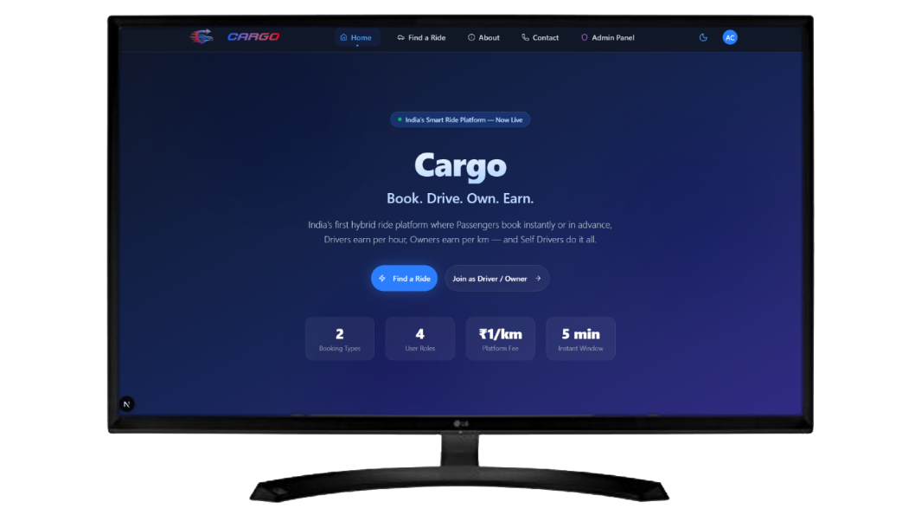
Mobile Size Landing Page (Lighter Theme)
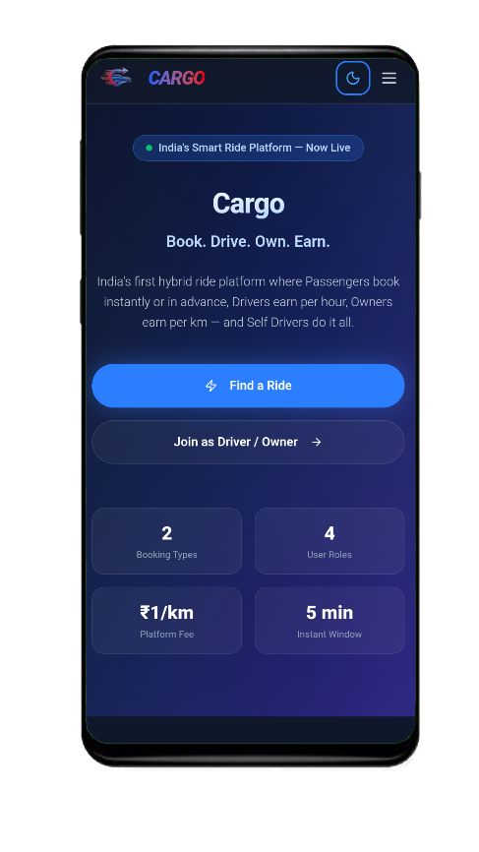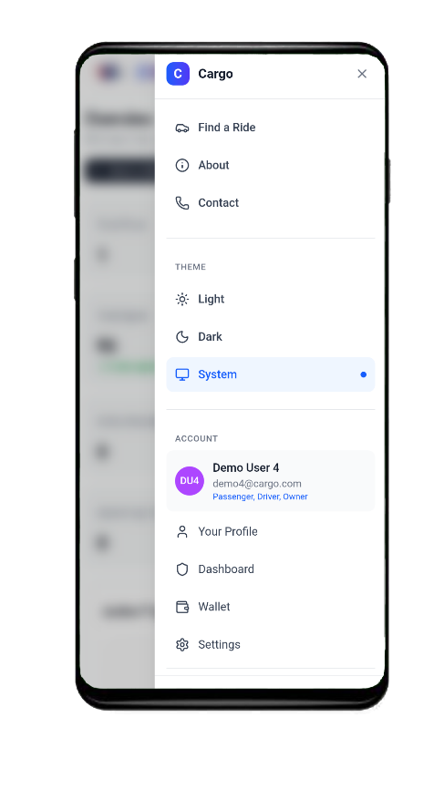
Login And Signup Page

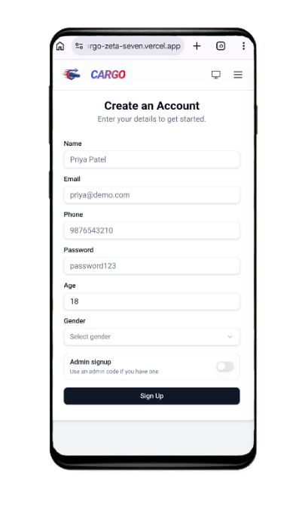
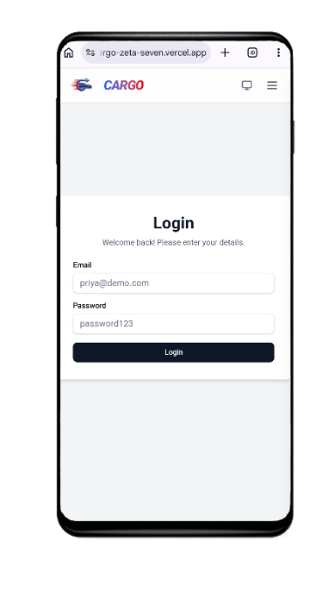
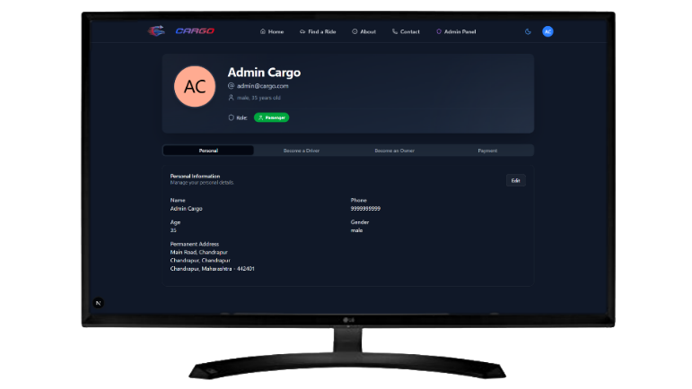
Profile And Role Update Page
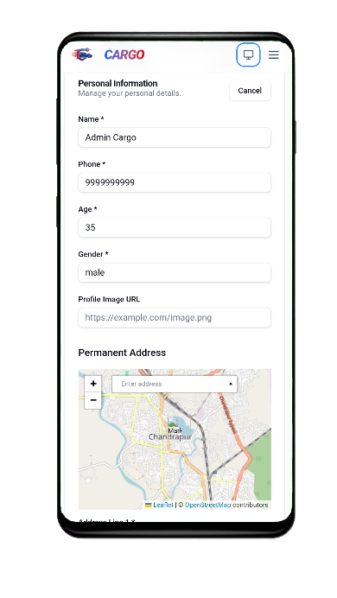
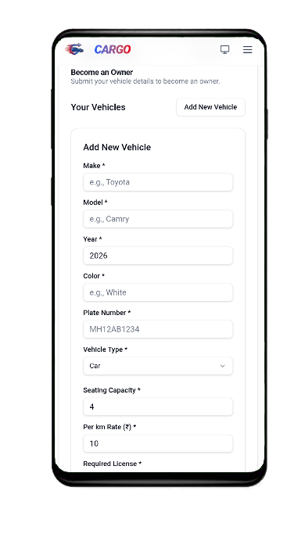
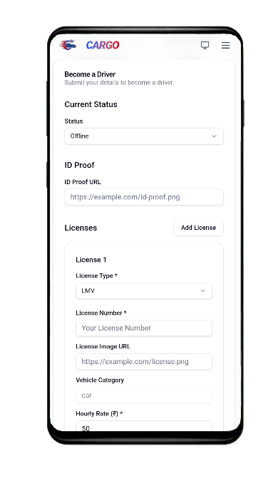

9.2 Unified Dashboard

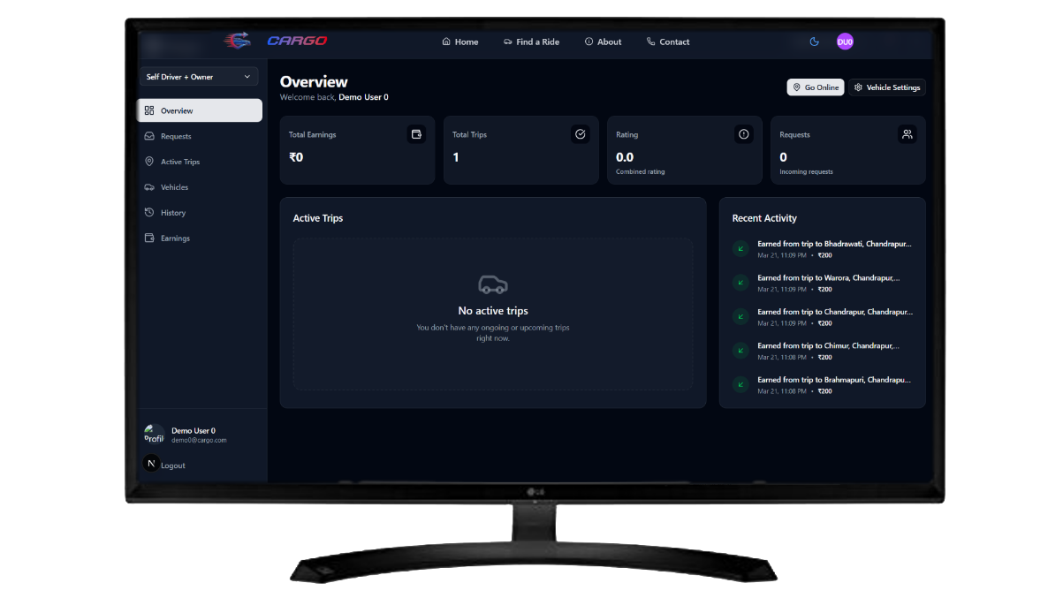
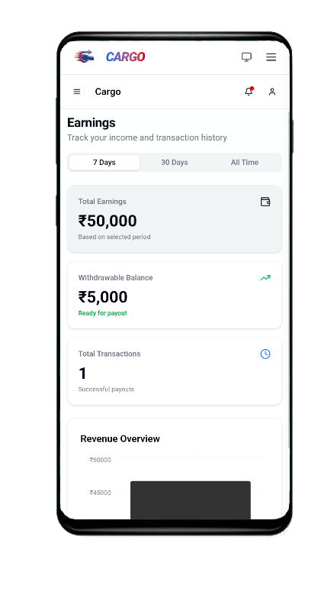
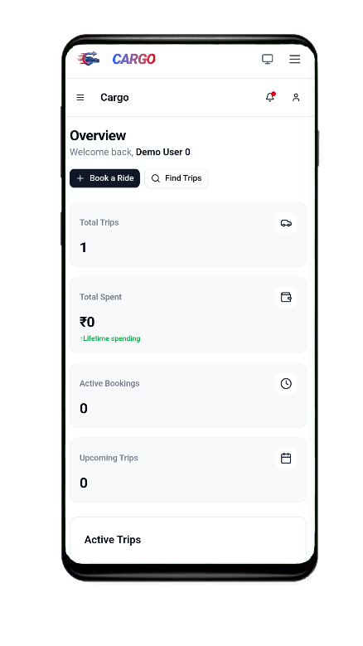
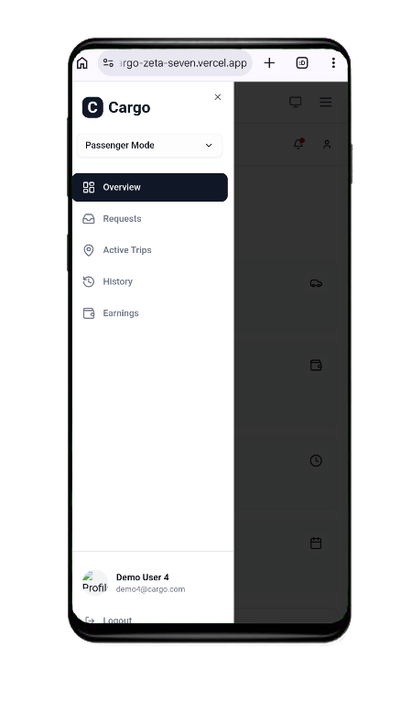

9.3 Ride Booking Interface
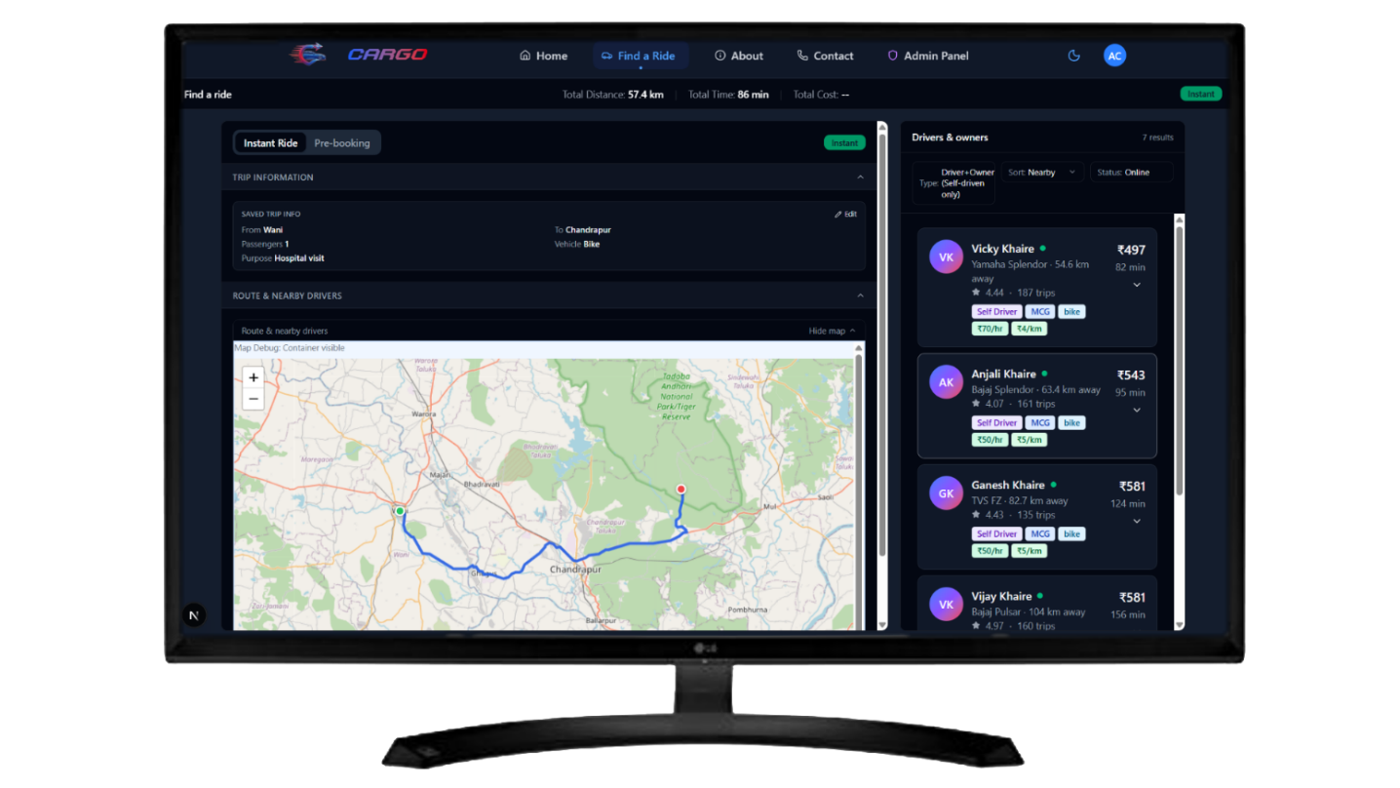

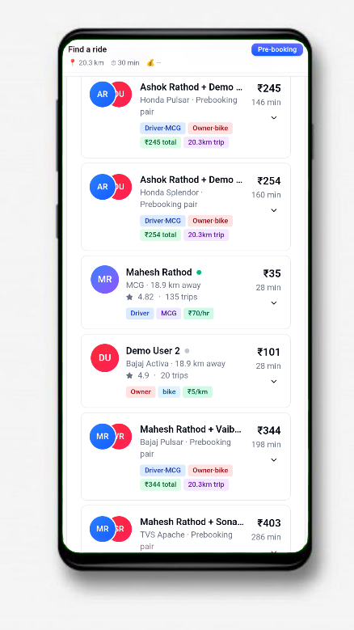
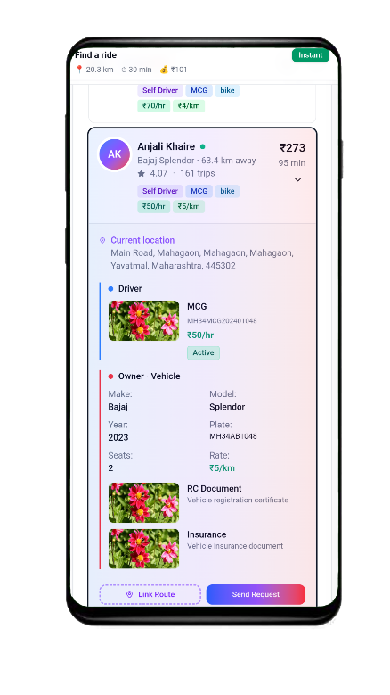
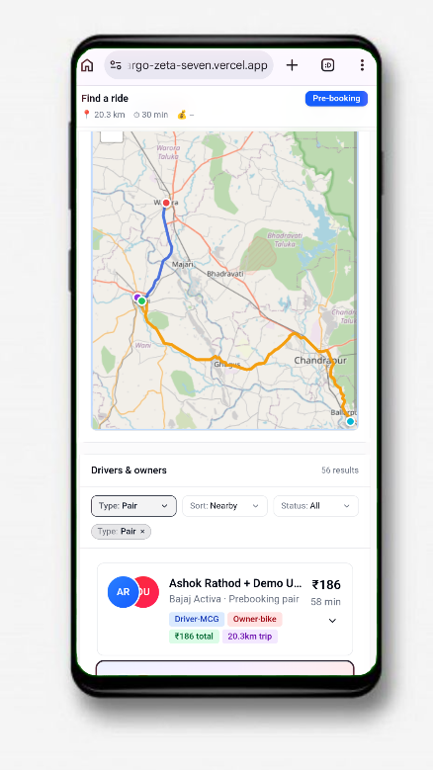

9.4 Wallet System

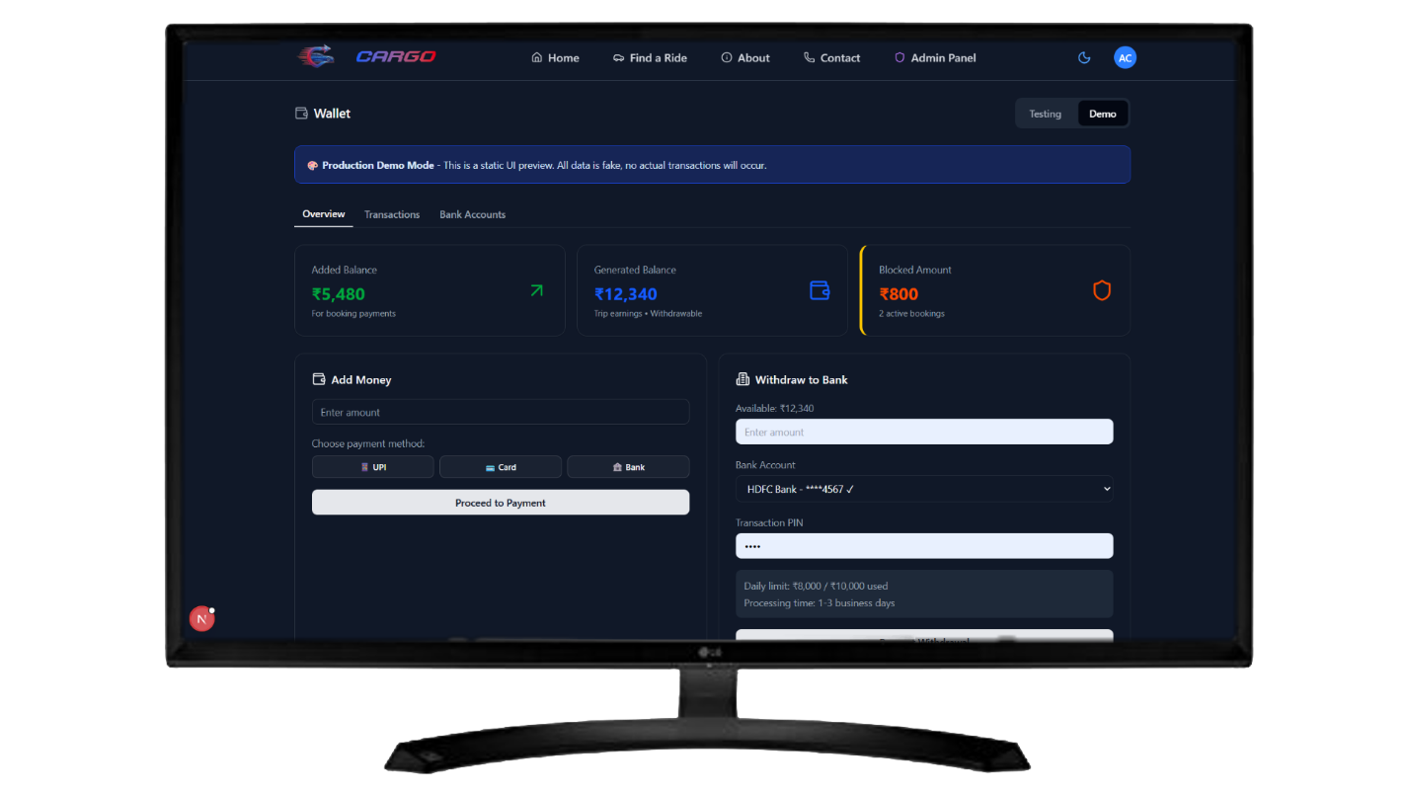
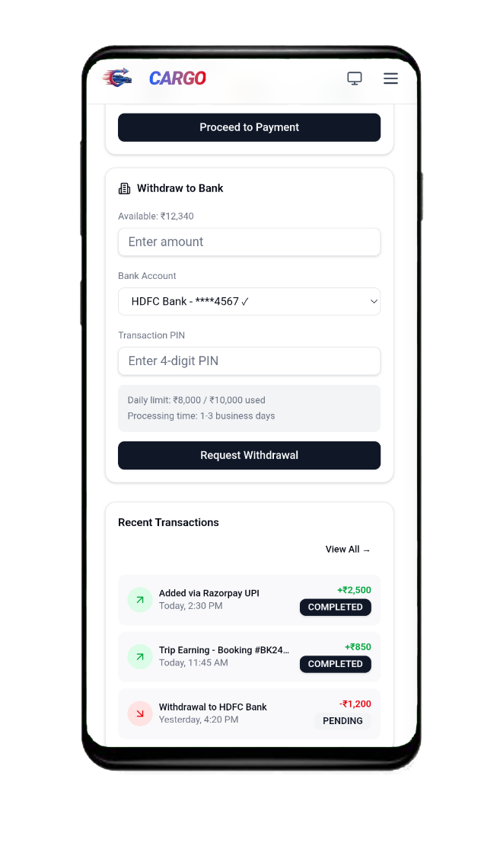
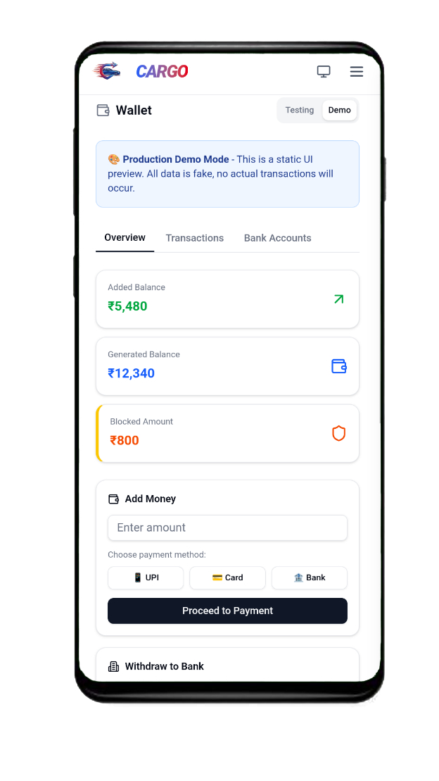

9.5 Admin Controls

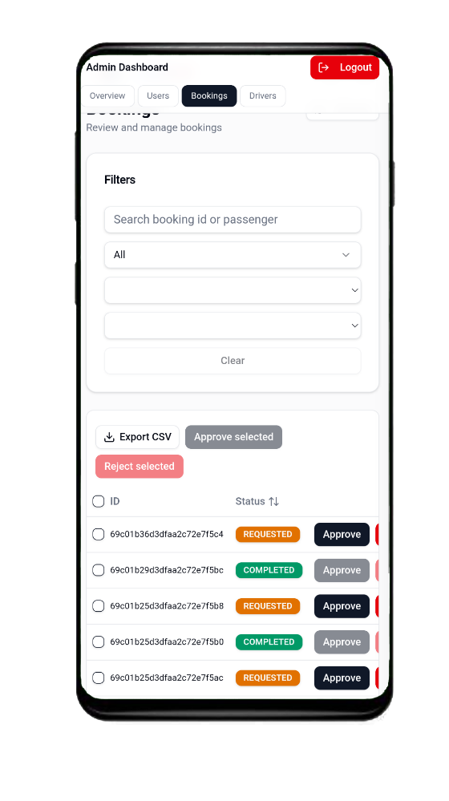
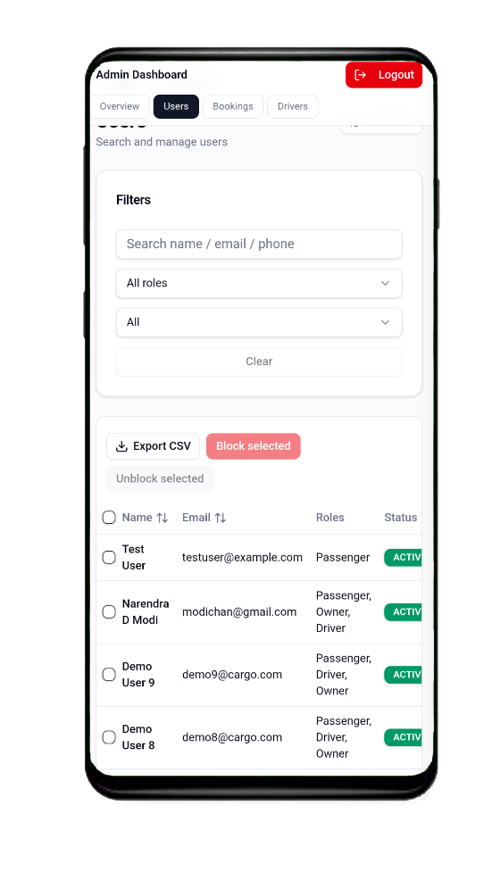
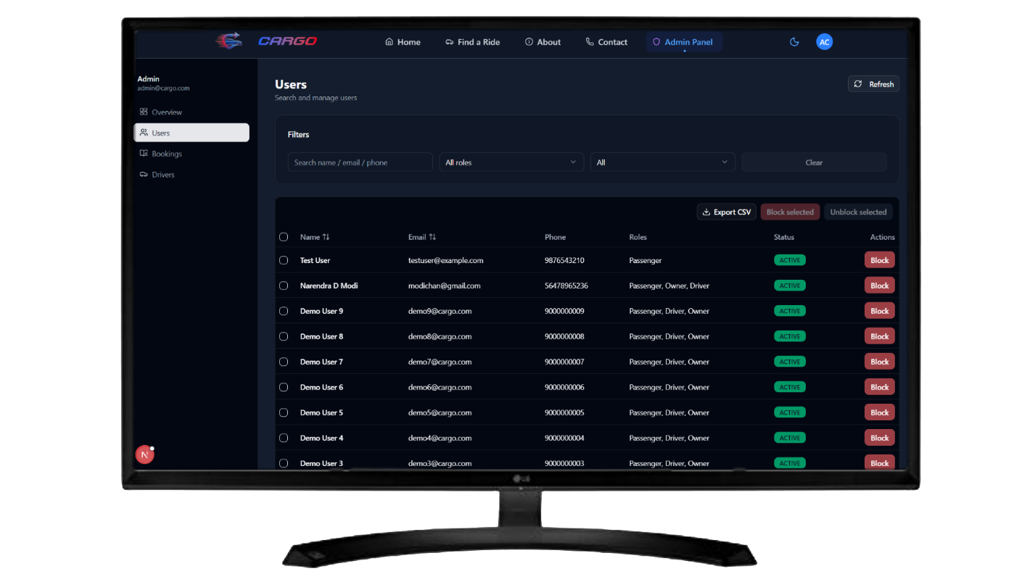

Chapter 9 — Future Development

10.1 Phase 2 — Core Operations (Live Launch)
Before public launch at the district level, the following features will be completed:
The Complete Trip Flow: Moving a booking from REQUESTED to ACCEPTED, ENROUTE, STARTED, and COMPLETED. This involves the driver physically engaging with the app during the ride to trigger timezone-accurate timestamps for actual fare calculation.
Razorpay Integration: Currently, wallet top-ups are simulated. Phase 2 involves registering Cargo as a business entity and authorizing strict UPI/Netbanking top-ups via Razorpay's Indian Gateway.
MSG91 OTP Implementation: Replacing fake numbers with real SMS verification to prevent spam user creation.

10.2 Phase 3 — Scale & Real-Time Functionality
Once stable at the district level, the platform will scale:
Real-Time Tracking (Sockets): Integrating Socket.io. When a driver enters the ENROUTE state, their phone's GPS will emit coordinates every 5 seconds, updating a live map on the passenger's screen.
Multi-Language Support (i18n): Because Cargo targets rural and semi-urban Indian demographics, forcing English UI restricts adoption. Marathi, Hindi, and local dialects will be integrated at the routing level.
Ola/Google Maps Migration: Replacing the free, open-source Leaflet map (which lacks real-time traffic data) with premium enterprise map APIs to ensure ETA calculations are accurate during rush hour.

Chapter 10 — Conclusion

11.1 Summary
Cargo was conceptualized to address a clear gap in the Indian transport ecosystem: the lack of a neutral, flexible aggregator for non-metro areas where rigid, platform-dictated pricing fails. Over the course of this project, we successfully designed, modeled, and developed a platform that respects the complex, 3-sided reality of local transport.
By decoupling the "Driver" from the "Vehicle", Cargo created a native short-term rental ecosystem. By introducing a hybrid "Self Driver" role alongside Pure Drivers and Pure Owners, the software accurately maps to how businesses operate in reality. Finally, by granting pricing autonomy (hourly vs per-km) directly to the operators and implementing a guaranteed "Pickup Charge", Cargo ensures a fair market environment.

11.2 Learning Outcomes
Building Cargo provided immense exposure to professional, full-stack software development:
- Architecture: Transitioning from four separate user interfaces to a single unified Next.js dashboard significantly improved understanding of React Context and modular component states.
- Database Design: Structuring a 9-schema NoSQL MongoDB database taught vital lessons regarding nested sub-documents (like driverInfo), referencing ObjectIds, and managing state across collections efficiently.
- Backend APIs: Writing complex $near geospatial aggregation queries provided insight into how major tech companies handle location services.
- Security: Implementing HTTP-only JWTs, password hashing, and explicit rate-limiting offered practical experience with essential web security concepts that theoretical studies often miss.

Bibliography / References
# | Source | URL / Details
1 | Next.js 15 App Router Documentation | https://nextjs.org/docs
2 | MongoDB Atlas & Geospatial Queries | https://www.mongodb.com/docs
3 | Mongoose ODM Validation Guidelines | https://mongoosejs.com/docs
4 | Tailwind CSS Utility Classes | https://tailwindcss.com/docs
5 | JWT (JSON Web Tokens) RFC 7519 | https://jwt.io/introduction
6 | Leaflet.js Open-Source Mapping | https://leafletjs.com

Project Links & Resources
Cargo — Smart Transport Aggregator Platform


GitHub
Source Code Repository
https://github.com/cargoproject9172/cargo/



Live Website
Deployed Project
https://cargo-zeta-seven.vercel.app/

Here
Thesis
Project Report (PDF)
drive.google.com / [ Your Thesis Link ]

